Fake news detection - A machine learning approach

Author
Muhammad Hilal Aslam Syed Ali

Supervisor
Dr Radu-Casian Mihailescu

MSc Data Science
School of Mathematics and Computer Science
A thesis presented for the degree of

April 2025

Acknowledgement

I would like to express my gratitude to everyone who helped me with my research. I am grateful to Dr Radu-Casian Mihailescu for giving me the opportunity to work under his expert guidance and supervision.
In addition, I would like to thank Heriot-Watt University for providing all the materials and resources required to accomplish this project. Pursuing a Master's degree was my ambition, and I am grateful to all the university staffs for their assistance in helping me achieve my goals.

Course code and name: | F21RP Research Methods and Project Planning
Type of assessment: | Individual
Coursework Title: | Fake news detection - A machine learning approach
Student Name: | Muhammad Hilal Aslam Syed Ali
Student ID Number: | H00484782

Declaration of authorship. By signing this form:

- I declare that the work I have submitted for individual assessment OR the work I have contributed to a group assessment, is entirely my own. I have NOT taken the ideas, writings or inventions of another person and used these as if they were my own. My submission or my contribution to a group submission is expressed in my own words. Any uses made within this work of the ideas, writings or inventions of others, or of any existing sources of information (books, journals, websites, etc.) are properly acknowledged and listed in the references and/or acknowledgements section.

- I confirm that I have read, understood and followed the University’s Regulations on plagiarism as published on the University’s website, and that I am aware of the penalties that I will face should I not adhere to the University Regulations.

- I confirm that I have read, understood and avoided the different types of plagiarism explained in the University guidance on Academic Integrity and Plagiarism

Student Signature (type your name): Muhammad Hilal Aslam Syed Ali

Date: 10/04/2025

Copy this page and insert it into your coursework file in front of your title page.
For group assessment each group member must sign a separate form and all forms must be included with the group submission.

Your work will not be marked if a signed copy of this form is not included with your submission.

Declaration of Authorship

I, Muhammad Hilal Aslam, declare that this thesis titled, ‘Fake News Detection Using Machine Learning’ and the work presented in it is my own. I confirm that this work submitted for assessment is my own and is expressed in my own words. Any uses made within it of the works of other authors in any form (e.g., ideas, equations, figures, text, tables, programs) are properly acknowledged at any point of their use. A list of the references employed is included.
Signed: Muhammad Hilal Aslam Syed Ali
Dated: April 10, 2025

Table of Contents

Acknowledgement 2
Declaration of Authorship 4
Table of Contents 5
Tables and Figures 6
Abstract 8
Chapter 1 9
1.1 Introduction: Fake News 10
1.2 Motivation 10
1.3 Aims and Objectives 11
1.4 Research Questions 11
1.5 My Contribution 12
Chapter 2 12
2.1 Literature Review 13
2.2 Background Study 13
2.2.1 The Rise of Fake News 13
2.2.2 Factors Influencing Fake News Propagation 13
2.2.3 Characteristics of Fake News 14
2.2.4 Traditional vs Modern Detection Approaches 15
2.2.5 Machine Learning & Deep Learning Techniques 15
2.2.6 Key Challenges 16
2.3 Machine Learning and Deep Learning Approaches 17
2.4 Related Works 18
2.5 Research Gap 22
Chapter 3 24
3.1 Methodology 24
3.2 Dataset Description and Preparation 25
3.3 Model selection and Architecture 26
3.4 Evaluation Metrics 27
Chapter 4 27
4.1 Implementation 27
4.2 Data Discovery & Labeling 28
4.3 Data Preprocessing & Cleaning 28
4.4 TF-IDF Vectorization 29
4.5 Classical Machine Learning Models 29
4.6 Deep Learning LSTM Models 31
4.7 Transformers 33
4.7.1 BERT 33
4.7.2 DistilBERT 36
4.7.3 RoBERTa 39
4.8 Ensemble Model Implementation 42
4.9 Model Explainability 44
4.9.1 Logistic Regression 44
4.9.2 Random Forest 45
4.9.3 BERT 46
4.9.4 DistilBERT 47
4.9.5 RoBERTa 48
4.9.6 Ensemble Model 49
4.10 Interactive Analysis Interface 49
4.10.1 Streamlit Deployment and Interface Limitations 50
Chapter 5 53
5.1 Comparative Model Analysis 53
5.2 Performance Comparison with Reference Studies 55
5.3 Cross-Dataset Evaluation on COVID-19 News 55
Chapter 6 57
6.1 Limitations of the Study 57
6.2 Challenges Faced 57
6.3 Key Conclusions 58
6.4 Future Enhancements 58
References 59

Tables and Figures

Figure 1. Comparative Analysis Table 22
Figure 2. Data Domain Split 28
Figure 3. Class Distribution 29
Figure 4.TF-IDF shape 29
Figure 5. LR & RF Model Evaluations (political) 30
Figure 6. LR & RF Model Evaluations (Non-Political) 31
Figure 7. LSTM Model Training (Political) 31
Figure 8. LSTM Model Evaluations (Political) 32
Figure 9. LSTM Model Training (Non-Political) 32
Figure 10. LSTM Model Evaluations (Non-Political) 33
Figure 11. BERT Training (Political) 33
Figure 12. BERT Training (Non-Political) 34
Figure 13. BERT Model Evaluations 35
Figure 14. BERT Error Analysis 35
Figure 15. DistilBERT Training (Political) 36
Figure 16. DistilBERT Confusion Matrix (Political) 37
Figure 17. DistilBERT Model Training (Non-Political) 37
Figure 18. DistilBERT Confusion Matrix (Non-Political) 38
Figure 19. DistilBERT Error Analysis 38
Figure 20. RoBERTa Model Training (Political) 39
Figure 21. RoBERTa Confusion Matrix (Political) 40
Figure 22. RoBERTa Model Training (Non-Political) 40
Figure 23. RoBERTa Confusion Matrix (Non-Political) 41
Figure 24. RoBERTa Error Analysis 41
Figure 25. Ensemble Model Evaluations (Political) 43
Figure 26. Ensemble Model Evaluations (Non-Political) 43
Figure 27. LR Explainability (Political) 44
Figure 28. LR Explainability (Non-Political) 45
Figure 29. RF Explainability (Political) 45
Figure 30. RF Explainability (Non-Political) 45
Figure 31. BERT Explainability (Political) 46
Figure 32. BERT Explainability (Non-Political) 46
Figure 33. DistilBERT Explainability (Political) 47
Figure 34. DistilBERT Explainability (Non-Political) 47
Figure 35. RoBERTa Explainability (Political) 48
Figure 36. RoBERTa Explainability (Non-Political) 48
Figure 37. Ensemble Model Explainability (Non-Political) 49
Figure 38. Interface 50
Figure 39. Streamlit Interface (1) 51
Figure 40. Streamlit Interface (2) 52
Figure 41. Used Models Comparison Table 54
Figure 42. Comparison with Reference Models Table 55
Figure 43. Model Performance on Covid Dataset 56

Abstract

The rapid spread of disinformation in the age of the internet poses a danger to destabilize politics, weaken public health, and tear society apart. Traditional fact-checking methods are effective but cannot match the rate at which false information spreads on the web. This project explores how machine learning (ML) and natural language processing (NLP) can be used to build a fake news detection system and also make it explainable and practical to use.

This study experiments with a range of models, including traditional ones like Logistic Regression and Random Forest, a deep learning model based on LSTM, and more advanced transformer models such as BERT, DistilBERT, and RoBERTa. Also a stacking ensemble model is created combining all the three transformer models. To make the predicted results understandable and explaining the classification factor, the model uses LIME for the simpler models & LSTM, and Transformer Interpret for the transformer-based ones.

The training is done with the ISOT Fake News Dataset and is also tested on a different COVID-19 fake news dataset in order to obtain the performance of the model on new data. The final model is implemented using the form of a simple interactive interface cell within the jupyter notebook to provide the users to feed a news article and get the prediction of each of these models along with the explainability factor for that prediction.

These efforts are aimed to provide the easily accessible and transparent tool which will help ordinary users, journalists, and researchers discover how they should understand the potentially misleading content more efficiently and properly.

Chapter 1

1.1 Introduction: Fake News
In today’s digital world, the spread of fake news has become a serious issue. Whether its influencing political matters or shaping public opinion during health crisis or creating social unrest the impact of misinformation is hard to ignore. For example, the 2016 US election’s social media engagement was largely influenced by fake news, and it gathered users’ attention more than the real news. Then during COVID-19 pandemic, we all know about the flooding of social media with misleading health advice and more. The WHO even came with the term “Infodemic” to describe just how widespread the danger of false information.

While traditional fact-checking efforts are helpful, they simply can’t keep up with the constant wave of new contents online. That’s when Machine Learning (ML) and Natural Language Processing (NLP) come in, offering ways to automatically detect fake news at a large scale. For this study, I will be using the ISOT Fake News Dataset, which includes over 17,000 fake news articles and more than 20,000 real ones, a solid foundation for building and testing fake news detection models.

1.2 Motivation
The urgency of this work comes from few critical gaps in the existing research. Firstly, while major platforms like Facebook and Twitter do use AI for moderating content, their systems are close off and not very transparent. This raise concerns around the censorship, bias and accountability (Gillespie, 2018). Secondly, Advanced models like BERT are powerful, but they don’t really explain why a piece of content is flagges as fake. This study will explore ways to make results more explainable, bridging the gap between accuracy and understanding. Finally, many fake news detection models still struggle with linguistic style patterns such as sarcasm or opinion pieces .etc, often leading to false positives.
Most publicly available datasets like LIAR or FakeNewsNet and even ISOT Fake News Dataset used in this study, focus mainly on political news and not on other major domains like healthcare and science. This project acknowledges that limitation of ISOT dataset and uses it as a starting point to build and test the models laying the foundation for future works. By addressing these gaps, this project aims to contribute to both academic discussion and real-world solutions

1.3 Aims and Objectives
The goal of this project is to create a fake news detection system that strikes balance between classification accuracy and interpretability. While much of the existing research has focused mainly on improving how well models classify news as real or fake, there’s been less attention on making deep learning models more understandable. This lack of transparency is a key barrier to their use in real-world decision-making. The project currently has three objectives;
Comparative Analysis: To compare traditional Machine learning models (such as Logistic regression and Random Forest) with deep learning models (like BERT, LSTMs, DistilBERT and RoBERTa). The aim is to understand the accuracy difference and computational efficiency between the models, to identify the best working model in different contexts.
Explainability: One of the main goals is to make the models more interpretable. We will implement attention mechanism and feature importance visualizations to help user understand why a piece of content is flagged as fake.
Deployment: To bridge the gap between complex research and real-world applications, to develop an interactive interface. This will allow users to input news article and receive real-time classification along with clear, understandable explanations of why those articles are flagged as fake or real.

1.4 Research Questions
The central question guiding this project is;
“How can machine learning be designed to detect fake news with high accuracy and explainability, while overcoming the limitations of politically biased training data?”
To explore this further, following sub questions are addressed;
- How do traditional ML models compare to deep learning architectures in detecting fake news across political and non-political contexts?
- What linguistic features (e.g., sensationalism, source citations) are most predictive of fake news when controlling for domain-specific biases?
- How can attention mechanisms or methods like SHAP values improve interpretability of model decisions for end-users?
- What ethical risks (e.g., over-censorship, cultural bias) arise when deploying fake news detection systems, and how can they be mitigated?
- Which evaluation metrics (beyond accuracy) best measure real-world impact, such as the cost of misclassifying legitimate news as fake?
- How can lightweight models maintain performance while reducing computational costs for scalable deployment?

1.5 My Contribution

This project contributes to the growing field of fake news detection by focusing not only on model performance but also on explainability and accessibility. Unlike many prior works that primarily aim to boost classification accuracy, this study adopts a more balanced approach by evaluating a diverse set of models including Logistic Regression, Random Forest, LSTM, BERT, DistilBERT, and RoBERTa. Combining them into a stacking ensemble for improved effectiveness.

A key aspect of this project is its use of interpretability tools. LIME is applied to traditional and LSTM models, while Transformer Interpret is used to explain the outputs of transformer-based models and the ensemble. This ensures users can better understand the reasons behind each prediction, which is essential for a context.

For real time analysis, an interactive interface cell is created within the notebook to enable the user to enter news articles and obtain the prediction in real-time by all the used models along with the explainability factor for it. The system is evaluated on both ISOT Fake News Dataset and a distinct COVID-19 fake news dataset, providing an idea of the degree to which it transfers to new data. These contributions will lead to more transparent, usable and adaptable solutions to identifying fake news in real-life environments.

Chapter 2

2.1 Literature Review
This chapter brings together what researchers have uncovered so far about fake news detection. It explores how fake news is defined, why it’s such a growing threat to society, and the various ways; both traditional and AI-powered that people have tried to combat it. The review dives into the key challenge; the most commonly used datasets, and the machine learning and deep learning methods that have shown promise. It also looks at how success is measured using different evaluation metrics. Finally, this chapter identifies the key gaps in current research, especially around model explainability and domain bias, which this project seeks to address.

2.2 Background Study

2.2.1 The Rise of Fake News
The words of Allcott and Gentzkow (2017) define fake news as “deliberately misleading content presented as genuine journalism” because it represents an escalating concern during the social media era. Numerous studies demonstrate how false information disseminates at a faster rate than truthful content across social media platforms according to Vosoughi et al. (2018). Major events such as the 2016 U.S presidential elections along with the COVID-19 pandemic have exposed the perils of misinformation to the public. Scientists from Zhou et al. (2020) emphasize how fake news creates extensive damage across political systems while distributing dangerous health information which involves serious risks.

2.2.2 Factors Influencing Fake News Propagation
False information spreads through the interaction of psychological aspects with technological elements. The demographic who shares fake news reports the most frequently consists of 18-28 year olds since they actively spend time on social media. People in older stages of life demonstrate greater caution while dealing with digital information yet struggle to understand digital platforms which increases their risk of being exposed to fake news that agrees with their beliefs system.
Biases further amplify the spread of fake news. Confirmation bias causes individuals to favor information that reinforces their pre existing views, leading them to readily accept and share content that share their beliefs regardless of its truthfulness. The novelty effect also plays a role as sensationalized and emotionally charged stories tend to attract more attentions and engagement making them go viral. Also social media algorithms are designed to prioritize engagement, unintentionally boosting the visibility of emotionally provocative fake news over genuine fact based contents

2.2.3 Characteristics of Fake News
Fake news exhibits several distinct linguistic and structural characteristics that sets it apart from legitimate articles. Large scale analyses of datasets like BuzzFeed News and PolitiFact have uncovered several key marks;

Emotionally Charged Language: Fake news headlines often feature exaggerated, sensationalized or alarming phrases (eg. “SHOCKING LEAK”) designed to provoke strong emotional reactions in readers. This emotional appeal makes the content more shareable and increases engagement, even if the story facts. According to (Vosoughi, Roy and Aral, 2018) fake news stories have stronger emotional reactions than real news.
Lack of Credible Sources: Misinformation often cites non verifiable or fabricated sources replicating legitimate news article which reference well established sources. This absence of verifiable sources diminishes the credibility of the content but may still be convincing enough to deceive the audience (Pennycook, Cannon and Rand, 2018).
Multimodal Deception: With advancing AI generated media, fake news now often takes the form of manipulated images and deepfake videos, which are visually difficult to detect. These technological advances makes it harder to differentiate real content from fabricated media, further complicating efforts to identify fake news.
Machine Learning models have been developed to identify these characters and the classification of fake news. For example, BERT based models analyze the semantic of text to identify inconsistencies or patterns commonly associated with fake news. Convolutional Neural Networks (CNN) operate to identify visual irregularities in modified images which strengthens a system's performance in identifying misinformation.

2.2.4 Traditional vs Modern Detection Approaches
The traditional approaches to fake news detection relied on manual fact checking by human experts. Organizations employed teams of researchers to verify claims by cross referencing sources, tracing origins and assessing accuracy. Even though this method yield high precision, its limited to low scaling and is time consuming, making it impractical for real time monitoring of social media contents.
To address this, rule based automated systems are developed, with predefined patterns to flag suspicious contents. They use keywords, analyzed sources and syntactic rules to carry out the classification. However even rule based method suffers from limitations like High false positives (satire or opinions are misclassified), Adaptability gaps and context blindness.

2.2.5 Machine Learning & Deep Learning Techniques
1. Traditional Feature Based Models:
Methods like Random Forest and Logistic Regression plays vital role in fake news detection, especially when dealing with structured data. These models work by combining the output of many decision trees making them immune to noise and missing values. Their transparency nature can highlight features which influences the prediction efficiency. In application, they have been successful in spotting bot accounts and low credible domains. However their reliance on predefined features makes them often struggle with unstructured data like raw data.

2. Transformers: (BERT and more)
With rise of deep learning, transformer models like BERT, DistilBERT and ROBERTa have significantly improved our ability on analyzing texts for identifying fake news. These models are trained on large volumes of text and are very good at understanding contexts, tones and emotionally expressed phrases. BERT has achieved excellent accuracy on benchmark datasets. But these models requires powerful hardwares to train and run and even small text changes and typos can make them inaccurate.

3. Explainability Approaches:
LIME (Local Interpretable Model-Agnostic Explanations) is a method of defining individual prediction by locally approximating complex models with simpler interpretable models. It points to significant features, e.g. key words in the text, which contribute to the decision of the model.
Transformer Interpret is a transformer-based method of visualizing attention and feature importance within transformers, where one can demonstrate what sections of input text the model pays attention to when making a prediction.

These two methods aid in increasing transparency in otherwise complicated machine learning models.

4. Future Directions:
Hybridize Graph Neural Networks (GNNs) with BERT for text and CLIP for images. GNNs can model network relationships. CLIP, capable of reading text as well as viewing images will help multimodal detection within news articles. Hybridization could make detection more accurate and implementation of more broader interface using streamlit.

2.2.6 Key Challenges
Ambiguity in Definition: Fake news shares many characteristics with several other deceptive news categories such as satire and opinion pieces and misinformation. Shu et al. (2017) explain that defining fake news from other deceptive content becomes challenging because fake news writers duplicate standard news media practices. The audience might misunderstand material in satirical news since such content usually includes impossible information and extravagant expressions. Automated detection systems face difficulties during training since they should differentiate between fraudulent content and other problematic types of content which intentionally avoid being deceitful.
Evolving Tactics: One vital obstacle involves the ongoing development of new methods that produce and spread false information. Deepfakes detection technologies create problems for existing detection systems as explained in (Chesney and Citron, 2019) and (Baptista and Gradim, 2022). Through deepfake technology users face immense challenges in recognizing fake multimedia content which both humans and algorithms find hard to detect even though these files are created from manipulated or fabricated digital materials. The manipulation of input data into adversarial examples creates a dangerous situation because the resulting subtle changes trigger detection system failures.

Scale: Online content quantity creates an extensive challenge when attempting to detect fake news. Meta announced in 2024 through its annual report that their team removed 3.5 billion fake accounts from their platforms during the year 2023 (Meta, 2024). Automated approaches which handle large volumes of content instantly have become essential to solve this problem.

Balancing Performance and Interpretability: Models based on transformers like BERT, DistilBERT, RoBERTa are computationally expensive and demand great use of GPU resources and training time. This is also restrictive to transparency as their sophisticated nature poses a challenge to users to comprehend the basis of making predictions. To solve it, explainability machines such as LIME or Transformer Interpret exist, yet it has little regard to performance.

Integration and Generalisation of Models: The process of designing a stacking ensemble which incorporates several models presents design issues more to do with compatibility, tuning and avoiding overfitting. Secondly, it is not a trivial issue to ensure that the models trained on one of the datasets (e.g., ISOT) behave well in another domain (e.g., on COVID-19 misinformation). These are important considerations in developing a system to perform reliably outside of its training context.

2.3 Machine Learning and Deep Learning Approaches
Linguistic & Feature-Based Classification: Feature-based classification methods function extensively for detecting fake news structures through the interpretation of linguistic features as their principal basis. According to (Pérez-Rosas et al., 2018) the characteristic element in fake news includes extreme language hyperbole. Fake news articles use strategically chosen emotional words which include "unbelievable," "shocking" as well as "horrifying" to interest readers. The identification of fake news becomes more possible through understanding these linguistic features combined with the analysis of positive or negative sentiment and achieved around 76% accuracy using methods like logistic regression.

Traditional Classifiers: Random Forest (RF) classifier is widely used in fake news detection studies. Wang (2017) introduced the LIAR dataset and utilized RF and SVM with n‑grams and credibility features to reach an F1‑score of approximately 92% on short statement classification. This underscores the effectiveness of feature-based classification when full-text data and topic detection models are available.

Deep and Sequential Models (LSTM): Sequential models such as LSTM have been employed to capture temporal and contextual dependencies in news text. Ma et al. (2016) demonstrated how LSTMs successfully model long-range linguistic patterns for rumour detection on social platforms, highlighting their usefulness in narrative-based fake news detection

Transformer Based Models: Fake news detection was greatly enhanced when BERT and Transformer architectures emerged. Khan et al. (2019) introduced FakeBERT, a hybrid of BERT and CNN layers to enhance ambiguity handling and context representation, achieving around 98.9% accuracy on benchmark datasets. Subsequent studies like Hayat et al. (2022) improved FakeBERT by adding stemming and TF-IDF preprocessing, pushing accuracy to nearly 99.7%. Meanwhile, benchmark studies such as Khan et al. (2021) confirmed that pre-trained models like BERT outperform traditional and sequential models even on varied datasets and smaller samples, especially when handling diverse news topics

2.4 Related Works
- Linguistic & Feature-Based Approaches
The research paper "Liar, Liar Pants on Fire: A New Benchmark Dataset for Fake News Detection" by (Wang, 2017) presented LIAR as a dataset with 12.8K statements that received seven specific classifications (true, false, half-true, etc.). Wang utilized SVM together with Random Forest (RF) using the combination of n-gram and credibility features to deliver an F1-score of 92%. The study established that linguistic and credibility features show promise for fake news detection yet fails to achieve proper distinction between various subtle levels like half-true statements.

In a similar vein, (Pérez-Rosas et al., 2018) used Logistic Regression for fake news detection on a dataset with exaggerated linguistic features. The model reached 75% accuracy which validated the significance of hyperbolic language yet identified that superior models would produce better outcomes.

- Deep Learning & Transformers
RNNs serve for detecting social media rumors per (Ma et al., 2016) by uniting temporal pattern information with social connection data including likes and shares. The team proposed a model that successfully spotted fake news indicators from the beginning indicating how social network data strengthens these detection systems.

(Khan et al., 2019)conducted research on BERT-based models for the FakeNewsNet dataset through adversarial training to boost the model's robustness levels. Detection performance strengths were confirmed through research because the system showed improved effectiveness in environments with noise and adversarial manipulations.

- Explainability & Stability
Considering the properties of both LSTM and Transformer model, explainability tools are necessary in the development of trust over the fake news detection systems.

In the case of classical ML models such as Logistic Regression or Random Forest, LIME (Local Interpretable Model-agnostic Explanations) (Ribeiro et al., 2016) has been shown capable of indicating which words or phrases had the greatest effect on a prediction. LIME works by perturbing the samples nearby an instance and locally fitting a simple interpretable model. The strategy is light and is suited to BoW or TF-IDF features. When applied in sequence-based models like LSTM, LIME can still be used. Even though it is approximate, its explanations are quite logical, and for short texts it is quite reasonable.

In the case of the Transformer-based models (BERT, DistilBERT, and RoBERTa) we use Transformers Interpet (Pierse, 2020), a Python package designed to leverage the internal self-attention weights of the models to create token-level visualisations of importance. The tool is model specific and introspective in nature of interpretation predictions and is achieved by emphasis on the tokens most influential to the model decision.

Although explanations from Transformers Interpret is based on attention capture, it should be mentioned that attention weights do not always reflect feature importance. Consequently, it is advisable to combine between different interpretability techniques to have an efficient result.

- Emerging Trends
(Zhang et al., 2023) developed an edge-operational system to detect fake news through lightweight LSTM models which work on smartphones and similar mobile devices. The system presents a latency under 50ms suitable for real-time verification applications that require users to authenticate news content while it is being consumed. The presented work demonstrates that quicker processing becomes possible but come with limitations in system complexity. The major drawback of such lightweight models is the sacrificing of some of the detailed contextual examining capabilities which deep learning models like BERT provide.
The study by (Bondielli and Marcelloni, 2019) of more than 150 papers about real-time detection systems identified important limitations in dealing with combined health and political domain applications. The studied lightweight LSTM-based architectures provide speedy decisions but demonstrate weak performance when applied to different subject matter according to their survey results. The problem becomes severe when the streaming data demands nonstop model processing.

Comparative analysis
Paper Author | Models Used | Methodology | Key Findings
(Wang, 2017) | SVM and Random Forest | Benchmark creation and SVM/RF classification | Utilized the LIAR dataset for detecting fake news through speaker credibility features. Found that speaker credibility is crucial, but social context was ignored, which limited its applicability in dynamic social media environments.
(Pérez-Rosas et al., 2018) | Logistic Regression | Supervised learning | Used a custom dataset with hyperbolic language cues for fake news detection. Achieved promising results in capturing emotional language cues but faced challenges due to cultural bias in the text data, limiting generalizability across regions.
Ribeiro et al., (2016) | LIME (Local Interpretable Model-agnostic Explanations) | Local perturbation-based explainability | Introduced LIME to explain predictions of any classifier by approximating the model locally. Enabled interpretable decisions for BoW and TF-IDF models.
Pierse (2020) | BERT, DistilBERT, RoBERTa | Transformer self-attention visualization using Transformers Interpret | Provided token-level importance visualization using attention weights for Transformer models. Enabled interpretability by highlighting attention limitations.
(Ma et al., 2016) | RNN + social engagement | Social network modeling and RNN | Explored rumour detection in microblogs, showing that early propagation modelling could help identify rumours. The reliance on real-time data for optimal performance is a limitation for large-scale deployments.
(Khan et al., 2019) | Adversarial BERT | Benchmark study | Demonstrated the versatility of BERT for fake news detection across various domains. However, it was computationally expensive and had challenges with scalability, requiring more efficient solutions.
(Shu et al., 2019) | Hybrid (Text + Social) | Hybrid model integrating text and social context | Integrated both text and social context features to improve fake news detection, offering a more holistic approach.
(Athaluri et al., 2023) | Adversarial BERT Defense | Adversarial training for text defense | Studied resilience to text perturbations in fake news detection. Achieved robust performance on the LIAR and custom datasets but was untested with multimodal data such as images or videos.
(Zhang et al., 2023) | Lightweight LSTM | LSTM for lightweight deployment | Proposed a lightweight LSTM for real-time deployment, achieving fast detection on COVID-19 related fake news. It performed well in edge environments but struggled with longer articles, showing a trade-off between speed and accuracy.
Figure 1. Comparative Analysis Table

2.5 Research Gap
The fake news detection study based on machine learning (ML) and deep learning (DL) has achieved remarkable growth. The traditional ML methods (e.g., SVM, Random Forest) have been superb in performance (accuracy = 75-92%) using linguistic and network features. Deep learning methods (e.g., BERT, RoBERTa) possess contextual and multimodal processing superiority with state-of-the-art performance F1 scores exceeding 90%.

Lack of Lightweight Real-Time Transformer Models: Though other experiments have suggested lightweight LSTM-based models and implementation that facilitated real-time detection as in (Zhang et al., 2023), many of these sacrificed context-awareness. Large-capacity heavyweight models like BERT provide outstanding contextual insight but they are resource-consuming and not suitable to implement on the edge computing device. This project examines how to trade-off performance and efficiency, in particular, using transformer-based models with GPU-based acceleration and future options to maintain efficiency using specialized edge-optimizing versions.

Limited Explainability Using Modern Tools: Much of the existing literature (e.g., Khan et al., 2019) & (Shu et al., 2019) discusses explainability in a generic sense. However, few works have operationalized model transparency using tools such as LIME (Ribeiro et al., 2016) or Transformer Interpret (Pierse, 2020). Our project explicitly integrates LIME for classical and LSTM models, and Transformer Interpret for BERT-based models, thereby addressing the need for actionable, local explanations tailored to both traditional and deep learning models.

Domain Generalization is Inadequate: Models like FakeBERT (Khan et al., 2019) perform well on political news datasets but fail to generalize across domains such as healthcare, finance, or pandemic-related misinformation. Our project directly addresses this issue by integrating a COVID-19 fake news dataset alongside general news, allowing us to analyze cross-domain performance and subject-specific errors.

Explainability and Bias in Detection: Few systems offer a unified interface that allows end-users to view different models prediction and its explanation of the prediction factor. This project proposes an interactive unified interface within the notebook where users can input an article, choose a model (Logistic Regression, LSTM, BERT, etc.), and view their predictions along with the explainability factor of that prediction. While some papers mention the presence of bias, there is little systematic effort to reduce it through fairness-aware training. This approach considers bias auditing by analyzing model outputs across different subjects (from the dataset) and using balanced data sampling strategies.

No Graph Based Model or Multimodal Integration: Although GNN-based models and multimodal algorithms such as EANN (Wang et al., 2018) have provided promising performance, they have rather complex input modalities (images, video, social graphs) that cannot be addressed within the scope of this work. Rather, our project is centered on text-based detection with Transformer models and sets the stage in a future extension to its multimodal form.

Chapter 3

3.1 Methodology
This section describes how an accurate artificial intelligence-based fake news system was developed through a systematic method. The method implements tested field techniques alongside solutions for preventing the recurring errors that past approaches encountered. All stages involved in building the fake news detection system start with detailed preparations that focus on high accuracy alongside usability and explainability while accounting for real-world unpredictability.

A specific workflow has been implemented for the methodology which combines reproducibility measures with practical application capabilities. This pipeline starts with the collection of data that is verified and undergone intensive preprocessing procedures that precedes the introduction of a dual-layer modelling framework that unites the classical and deep architecture. The performance of a model is assessed with both quantitative and qualitative variables in order to provide the full scope of effectiveness. The objective is to come up with not only precise forecasts, but also usable information that can be helpful to policymakers as well as the platform operators to battle against fake news.

3.2 Dataset Description and Preparation
The ISOT Fake News Dataset provides more than 40,000 professionally verified articles those have declared real or fake status. Articles within this dataset derive from two distinct sources that merge fact-checked misinformation found on PolitiFact and Snopes with credible material from Reuters and The New York Times. The available dataset contains detailed textual material in which readers can access article text and headlines together with metadata describing publication times and source addresses for conducting text analysis and tracking content changes through time. The expert fact-checker labelling achieved excellent reliability standards and the diverse political nature of sources enables broad generalization of the model.
During preprocessing the data, the pipeline carries out essential data transformation processes which focus on making the data ready for analysis. The processing of textual data involves several stages that first erase HTML elements plus special symbols and non-ASCII components yet protects essential semantic relationships from being lost. The advanced tokenization process preserves word relationships by applying expert treatment to specialization terms and recognizable entities. The feature engineering process brings out three crucial linguistic measures from texts: VADER sentiment analysis profiles and readability measures through Flesch-Kincaid calculations and lexical diversity indicators which help detect machine-generated content. The feature-engineering process extracts time-related information from publication metadata to detect patterns that appear during misinformation cycles.

Our strategy includes two solutions that address data quality problems: articles with shortened content use headings as context unless otherwise specified yet keep sections visibly marked when textual reconstruction is partial. Since the original data has a relatively good balance in terms of the distribution of the classes (around 55% real and 45% fake), it wasn’t required to use any oversampling procedure like SMOTE. So suitable evaluation metrics and model strategies were used in order to avoid the introduction of synthetic data that treat the classes differently.

3.3 Model selection and Architecture
Both interpretability and contextual power require the consideration to be fairly balanced to contribute to the advantage of the system, thus the multi-model system that relies on both classical ML and deep learning methods is applied:

Random Forest: Selected due to its efficiency against overfitting and can also handle high-dimensional sparse feature spaces as in TF-IDF. It also gives baseline interpretability in terms of scores of feature importance.
LSTM (Long Short-Term Memory): It was used to model long-range word dependence and temporal dependencies of language in sequence of texts.

Transformer Models: Binary classification is fine-tuned into three pre-trained transformer-based models namely, BERT, DistilBERT and RoBERTa. Such models are selected because of their leading-edge performance and capability of interpreting rich contextual data.
Stacking Ensemble: A meta-classifier (Logistic Regression) is trained on the prediction probabilities from all individual models to form a unified prediction strategy. This architecture augments generalizability and lessens the drawbacks of any particular model.

The implementation of modeling components is done using scikit-learn (in the classical model) and the Hugging Face Transformers library (in the deep learning model) with custom PyTorch dataset classes ensuring flexibility and GPU-accelerated training.

3.4 Evaluation Metrics
The In order to achieve a relevant assessment in a cross-distribution of the classes, the following metrics are taken:
Macro-averaged F1-score: Measures balanced performance of the fake and real categories.
Matthews Correlation Coefficient (MCC): A reliable summary used in the case of an imbalanced binary classification task.
The Confusion Matrix Analysis: Determines the kind of misclassifications particularly important for safety-critical use cases.
Additionally, an inter-topic error analysis is performed to determine model performance over topic areas (e.g., politics vs health) using the subject column in the data set. For model interpretability: To define local explanations of individual prediction, LIME (Ribeiro et al., 2016) is applied to the Random Forest, Logistic Regression and LSTM model.
Transformer Interpret (Pierse, 2020) is applicable on BERT-based models to provide an explanation of attention-based contributions on token level. Such tools of explainability offer necessary transparency to confirm trust of users and facilitate model debugging and decision support.

Chapter 4

4.1 Implementation
This chapter describes the implementation of the fake news detection system which was created based on a dual domain strategy; political and non-political news. The domain separation ensures no leakages between the class contexts. The implementation pipeline has a layered implementation of data acquisition, cleaning, feature extraction, model training, evaluation and explainability.

4.2 Data Discovery & Labeling
The model loads the ISOT Fake News Dataset, and divides it into two separate fields each according to the subject field:
Political domain: Articles where subject column has attributes "politics" or "politicsNews".
Non-political domain: All other subjects.
Each article was tagged with labels; 0 for fake and 1 for real. The datasets were shuffled to eliminate ordering bias and exported for future use.
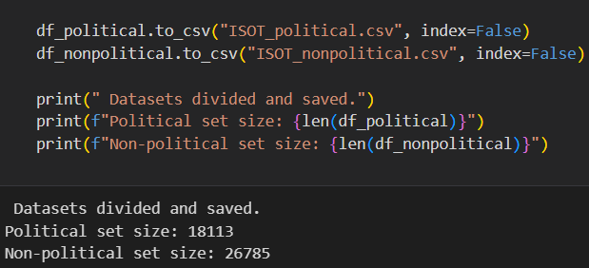
Figure 2. Data Domain Split

4.3 Data Preprocessing & Cleaning
The title and text fields were combined into a new column to maintain domain integrity, and then cleaned to remove URLs, HTML tags, special characters, headers (e.g., “WASHINGTON -”, “REUTERS”), digits, etc. The cleaned data was saved as separate csv files.
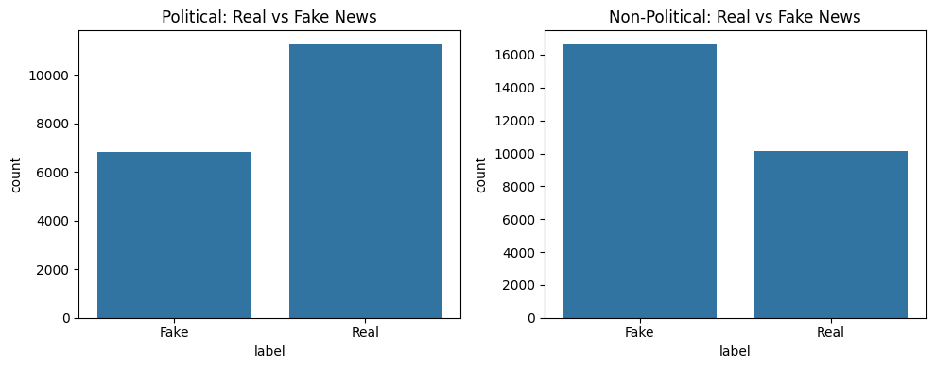
Figure 3. Class Distribution

4.4 TF-IDF Vectorization
The dataset was divided into Politcal and Non-political domains with each subset splitting into 80% train and 20% test sets. Using TF-IDF with max features limited to 5000 and N-Gram range = (1,2), text features were vectorized separately for each domain.

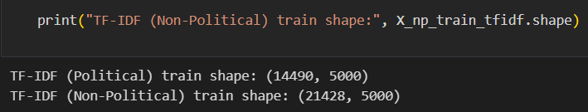
Figure 4.TF-IDF shape

4.5 Classical Machine Learning Models
For both political and non-political domains, two ML models were trained; Logistic Regression (default parameters with 1000 set as max iteration) and Random Forest (200 trees, max depth 50 and a random state of 42). Each models were evaluated using Accuracy, Precision, Recall, F1-score and Confusion Matrix visualization.

For POLITICAL Domain dataset;
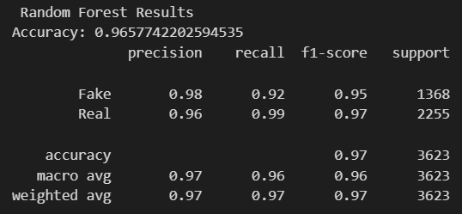
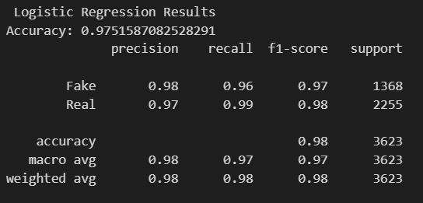
Logistic Regression Accuracy: 97.52% Random Forest Accuracy: 96.58%
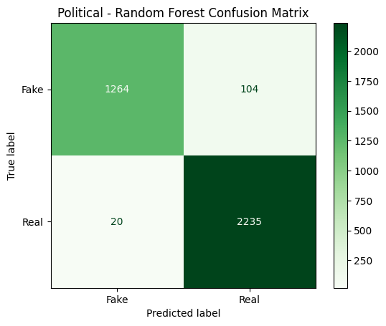
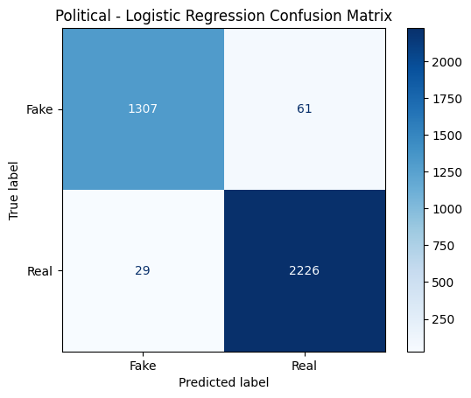

Figure 5. LR & RF Model Evaluations (political)

For NON-POLITICAL Domain dataset;
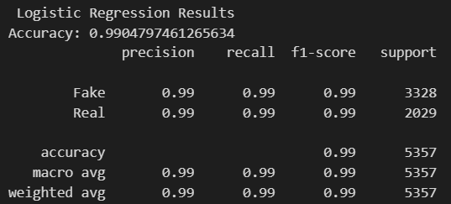
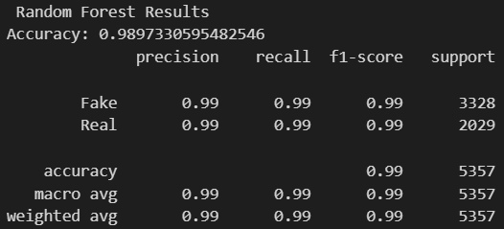
Logistic Regression Accuracy: 99.05% Random Forest Accuracy: 98.97%
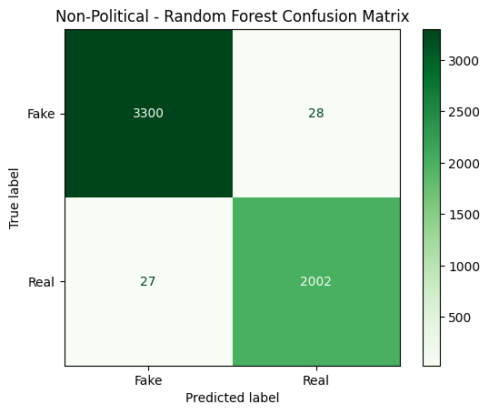
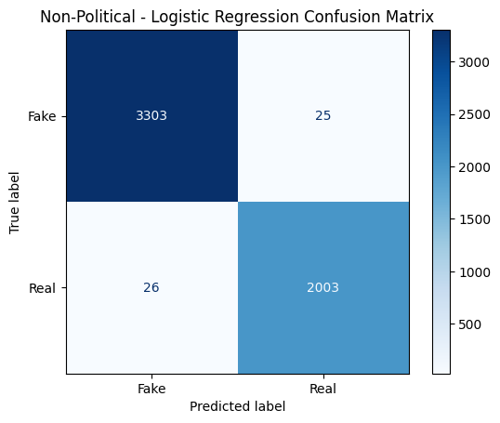
Figure 6. LR & RF Model Evaluations (Non-Political)

Political Domain: Compared to Random Forest (96.58 % accuracy), Logistic Regression performed better (97.52 % accuracy), especially on identifying fake news (greater recall).

Non-Political Domain: Both of these models performed nearly the same (~99% accuracy), which might be an indication of simpler text patterns within the domain.

4.6 Deep Learning LSTM Models
A sequential LSTM model was trained with the architectures; Embedding layer: 10,000 vocab, 128 batch size and 5 epochs.

For POLITICAL Domain dataset;
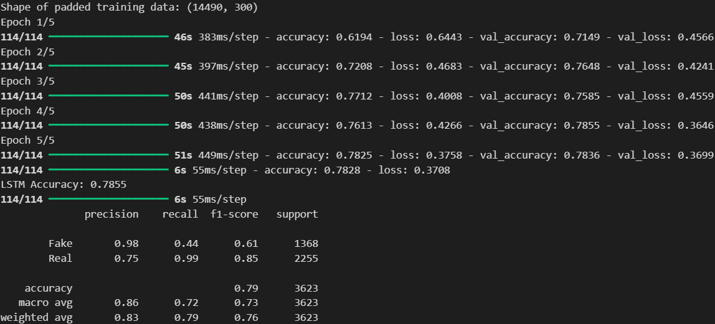
Figure 7. LSTM Model Training (Political)
Final Accuracy: 78.55%

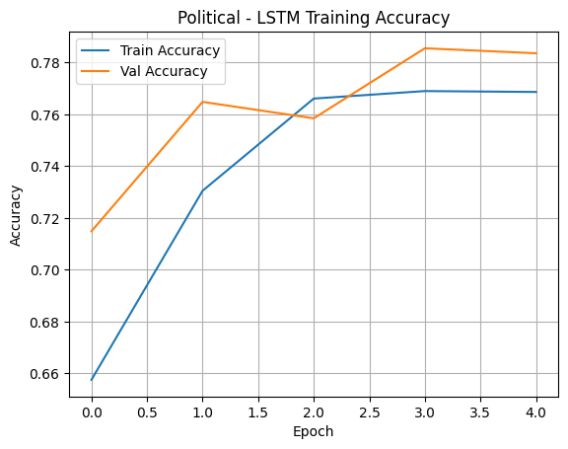
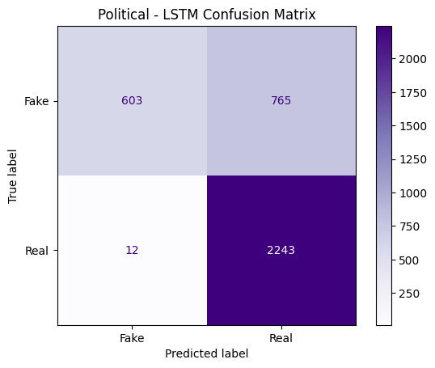
Figure 8. LSTM Model Evaluations (Political)

For NON-POLITICAL Domain dataset;
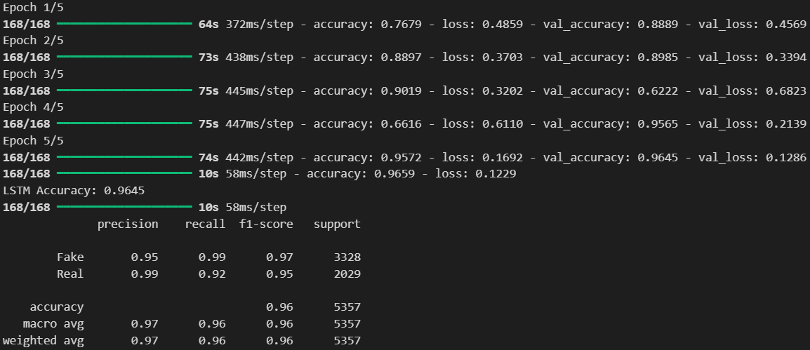

Figure 9. LSTM Model Training (Non-Political)

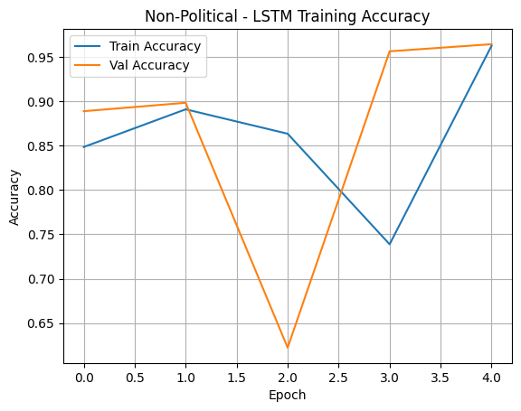
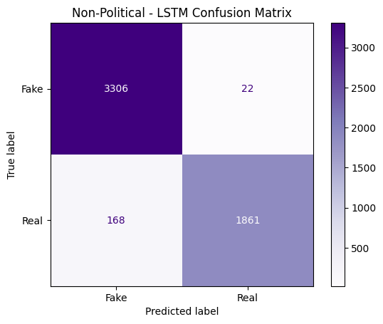
Figure 10. LSTM Model Evaluations (Non-Political)

4.7 Transformers

4.7.1 BERT
The BERT based model was fine tuned using PyTorch GPU acceleration. For both the dataset domains, the model was trained for two epochs with a batch size of 16. The political domain model achieved exceptional performance with 99.94% accuracy after training for approximately 1 hour 56 minutes. Interestingly, the model reached near-perfect metrics after just the first epoch, with only marginal improvements in the second epoch.

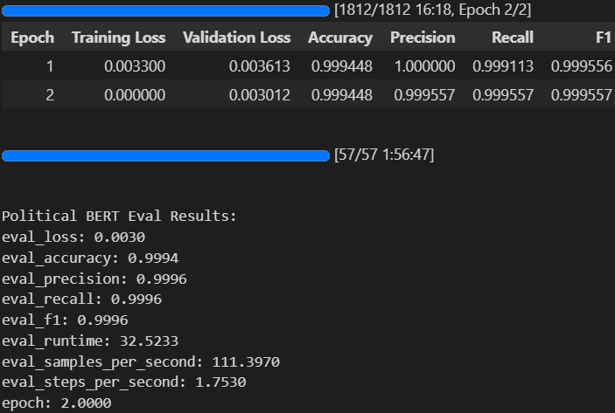
Figure 11. BERT Training (Political)
The non-political domain model demonstrated similarly outstanding results, attaining 99.96% accuracy requiring slightly lesser training time of about 1 hour and 42 minutes. Notably, this model achieved perfect recall by the second epoch, correctly identifying all real news articles in the test set, while maintaining 99.90% precision. The analysis findings show that BERT exceeded the performance of all prior methods, scoring very high on both domains in the classification process. We can conclude that due to the well-suited attention mechanisms and contextual embeddings of BERT, we can effectively implement it for detecting fake news. The political domain showed slightly better precision (99.96% vs 99.90%), whereas, in the non-political model showed perfect recalls. These slight variances could just be natural attributes of the respective datasets and in the case of political news there is a possibility of having more subtle clues on which to classify the data.
Some difficulties in implementation were the restrictions on GPU memory that is used during training and the need to maximize the batch size to process efficiently. The method utilised gradient accumulation and mixed-precision training when it was needed. A further exploration may consider model distillation approaches to reduce the computational requirement maintaining high accuracy and allowing applications in systems with limited resources. The present findings position BERT as an exceptionally effective baseline to detect fake news in the political as well as non-political fields.

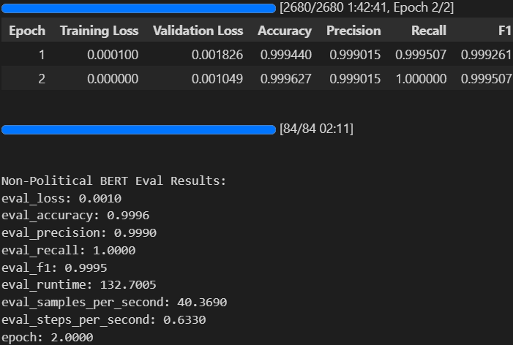
Figure 12. BERT Training (Non-Political)
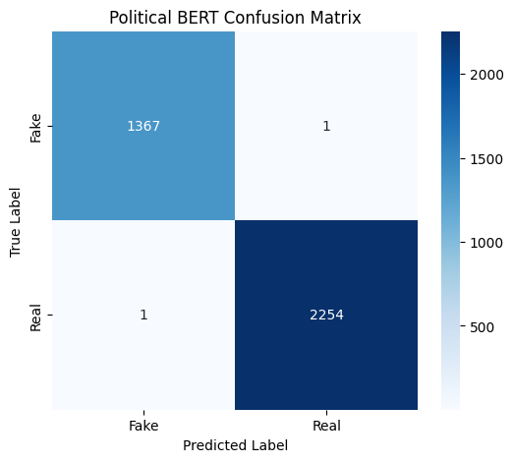
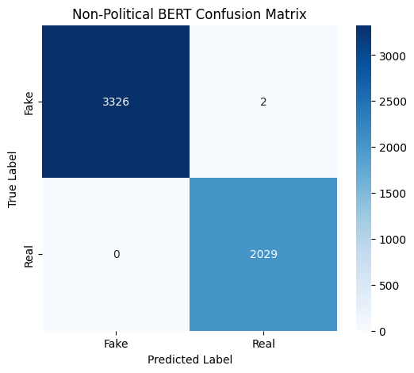
Figure 13. BERT Model Evaluations
ERROR ANALYSIS:
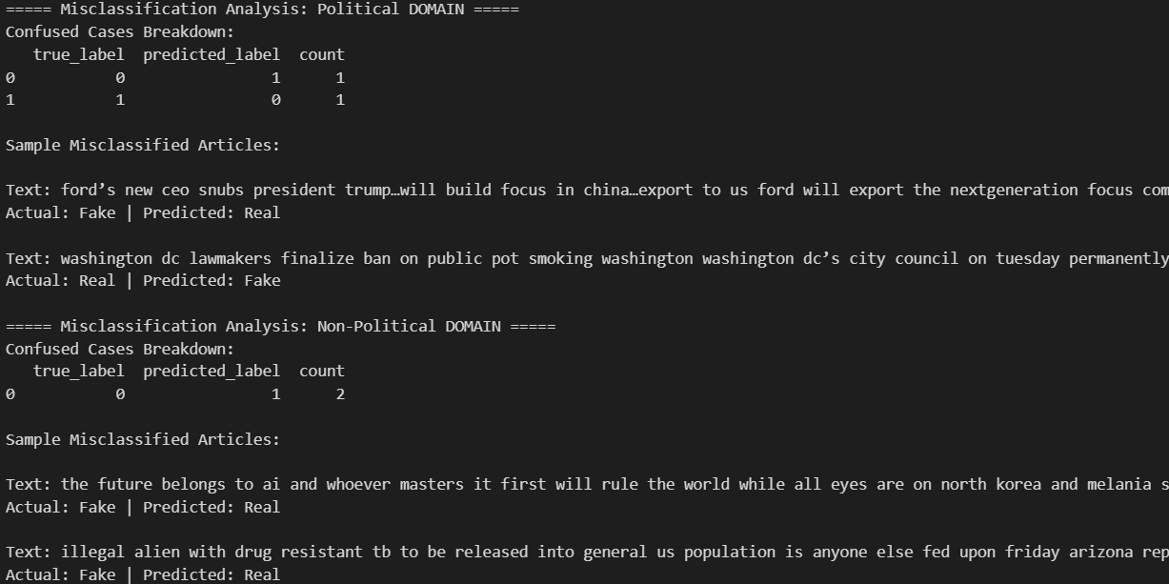
Figure 14. BERT Error Analysis
There were only two misclassified examples of the political domain of 3,623 test samples in BERT model (an error rate of 0.055 percent). The errors were balanced in their distribution, one false positive (Fake news correctly predicted as Real), and one false negative (Real news correctly predicted as Fake). In the false positive case, the article covering the manufacturing products decisions at Ford company displayed defining elements of fake news, i.e. hyperbolic statements regarding executive decisions and impact on international trade. The falsely negative case involved a genuine policy announcement of the marijuana legislation in the state of Washington DC, which the model might have noted because of the highly contentious nature of the story or on stylistic grounds because of the similarities to made-up political texts.
The model performed two mistakes in the non- politics domain, both of them false positives, when the fake news was incorrectly classified as the actual one. The falsely labeled commitments had some major characteristics in common: they contained promises of innovations and geopolitics, they used emotionally biased terms of language ("will rule the world, I am fed up") and mentioned authoritative characters (Elon Musk, government regulations). Such tendencies indicate the model might have trouble dealing with advanced fake news that emulates authentic forms of reporting, but also includes inflammatory statements. Lack of false negatives in this area implies that the model would be quite conservative in analyzing the non-political content, assuming that dubious content is questionable rather than a risk of suppressing the honest news.

4.7.2 DistilBERT
The DistilBERT model was implemented for a more optimized version of the full BERT architecture while maintaining strong classification. Through the use of a distilled version of BERT (DistilBERT-base-uncased), we were able to attain a similar level of accuracy with considerably less requirements of computations. The initial setting of the model used sequence classification head for binary classification. The DistilBertTokenizerFast was used for tokenizing text inputs with the maximum sequence length of 256. The training setup consisted of a batch size of 16 samples per device over 2 training epochs and weight decay regularization (0.01) was used to prevent overfitting. The accuracy, F1-score and precision and recall evaluation indices were recorded after every epoch.

Performance of Political Domain: DistilBERT was nearly 100 percent accurate on the political news test set (accuracy, F1-score, precision and recall). This extraordinary performance was observed in both training epochs as validation loss reduced in epoch 1 which was 0.000315 to 0.000047 in epoch 2. The completion time of training the 14,490 training examples took a total of just around 8.5 min, which serves as the evidence of efficient processing.
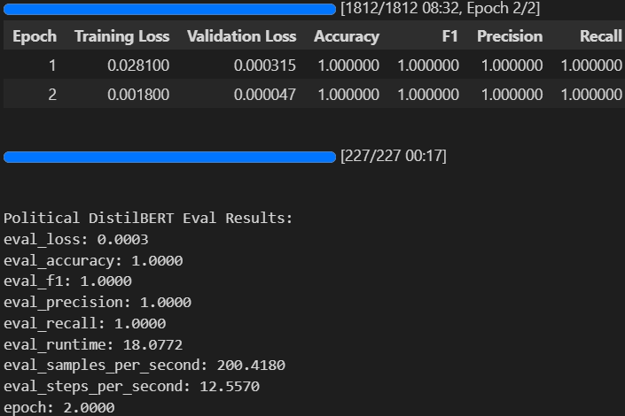
Figure 15. DistilBERT Training (Political)
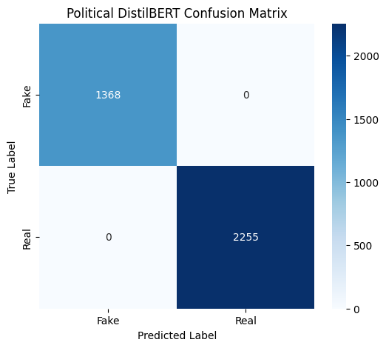

Figure 16. DistilBERT Confusion Matrix (Political)

Non-Political Domain Performance: The model achieved a 99.94 percent accuracy with precision of 100 percent and close to perfect recall of 99.85 percent. The F1-score of 99.93% implies that the balance between precision and recall is great. The training took an approximate 12.5 minutes on the larger pool of 21,428 sample. The loss of validation was between 0.005783 to 0.002944 in between the epochs.

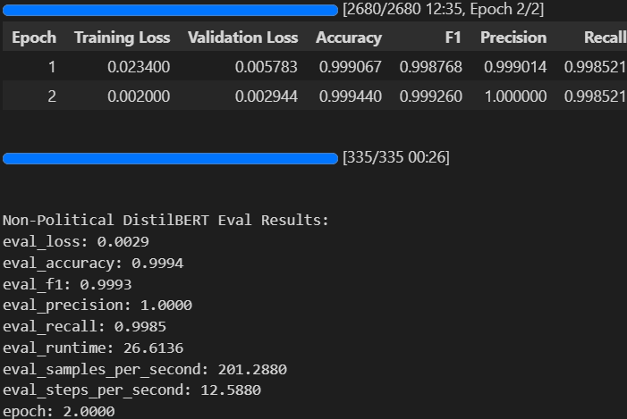
Figure 17. DistilBERT Model Training (Non-Political)
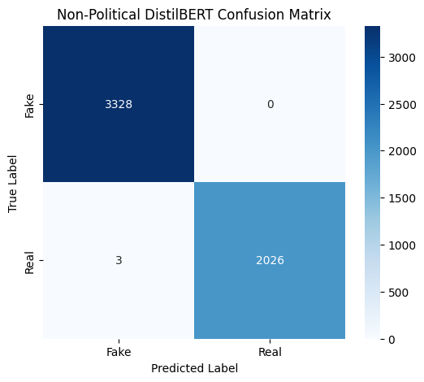
Figure 18. DistilBERT Confusion Matrix (Non-Political)

ERROR ANALYSIS:
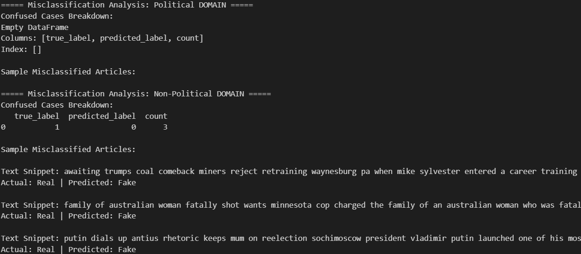
Figure 19. DistilBERT Error Analysis

On political news, the DistilBERT model demonstrated a 100 percent accuracy across all 3,623 test examples. This perfect behavior implies that the distilled model had successfully acquired the unique patterns that represented the authentic and fake political contents.

In the case of non-political news, there were only three errors but all false negatives in which legit articles were flagged as fake. These false news items were similar in nature as they touched on sensitive content (international affairs, policing), were written in emotionally wrought language and adopted the style of sensational reporting. The mistakes indicate that the model sometimes has a hard time with authentic news that have controversial subject matter that have stylistic features in common with fake news.

The observation of no errors in political domain versus very few non-political error means that political fake news might have a more specific feature. The model shows caution when it comes to sensitive topics. This pattern shows a curious asymmetry, because although the model finds it easy to detect political deception, it still is more prone to inquire on legitimate reporting of non controversial issues, which happen to be non-political. Future refinements can be made on the delicate reporting while ensuring that the existing model remains perfect in reporting political news.

4.7.3 RoBERTa
The RoBERTa-base model was also fine-trained to detect fake news with an outstanding level of performance in both fields. In politically related news, the model got near-perfect classification (99.97 accuracy, 100% recall) after a long 1 hour and 11 minutes training of two epochs. Validation loss decreased by 0.0132 to 0.0005 implying quick convergence. Testing indicated balanced results of 99.96 precision and 99.98 F1-score with 276 samples/second inference.

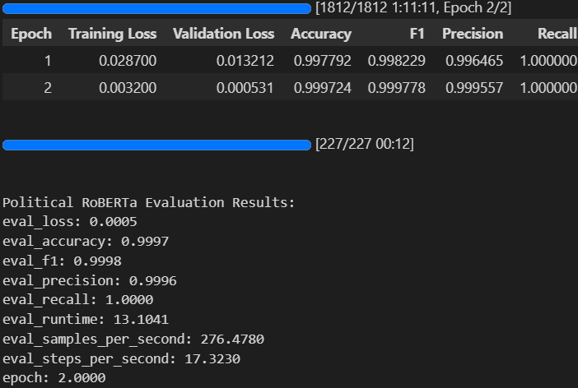
Figure 20. RoBERTa Model Training (Political)

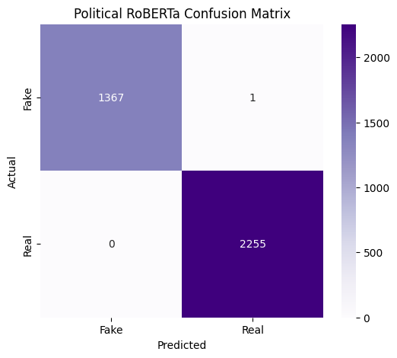
Figure 21. RoBERTa Confusion Matrix (Political)

Results obtained by non-political news classification were a bit lower yet quite good (99.78% accuracy, 99.70% F1). It demanded substantially more computational time; taking 2 hours and 39 minutes to run 2 epochs. The model showed consistent improvement with each epochs, validation loss decreasing to 0.0627 and 0.0131 respectively. The performance metrics remained balanced, and there were the same levels of precision and recall (99.70 percent), indicating equal performance in identifying fake and real news. The speed of evaluation was reduced (22 samples/second) because the size of the dataset was more significant.

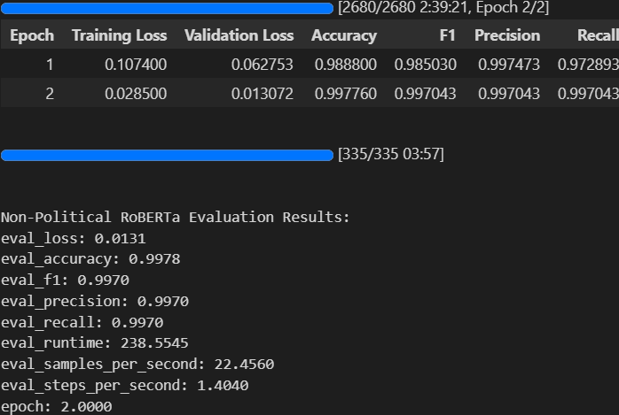
Figure 22. RoBERTa Model Training (Non-Political)
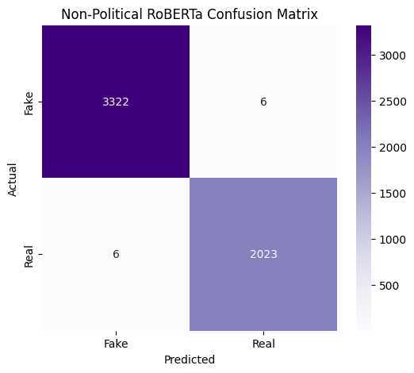
Figure 23. RoBERTa Confusion Matrix (Non-Political)
The speeds of evaluation on the political news were processed at 276 samples/second though the non-political material was only at 22 samples/second. Such a performance highlights the computational tradeoffs in powerful transformer models, where accuracy improvement is gained at an exponential cost in the time spent to process larger and more heterogeneous data. Based on the outcomes, it can be concluded that although RoBERTa can produce impressive performance in terms of classification, it can still be of limited application due to the careful consideration of the computational resources that need to be taken into account regarding some time-sensitive tasks.

ERROR ANALYSIS:
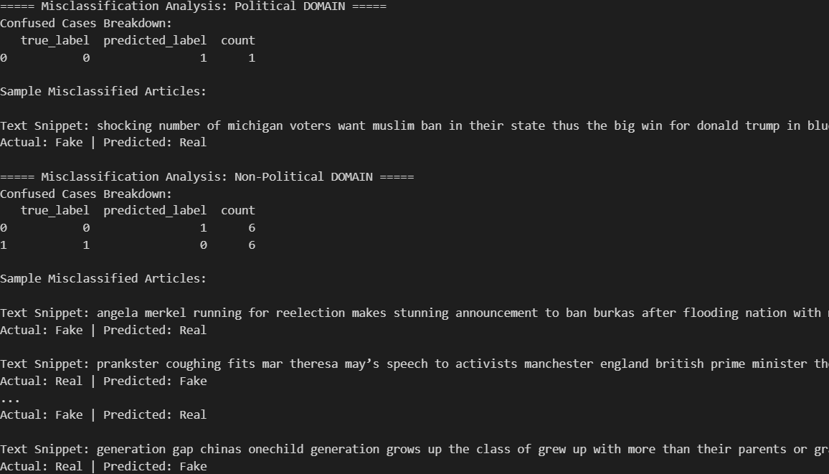
Figure 24. RoBERTa Error Analysis
On political news, the RoBERTa model performed almost perfectly, with only one test political article being miscalculated. This is a case of false positive where a fake article which carries sensational political claims and emotionally charged words was categorized as real. The rarity of these mistakes implies that RoBERTa has a firm understanding of the stylistic and linguistic cues that can be used to identify fake political news.

In the non political news, however, the model was demonstrating much more equal ground on error distribution with both domains having six false positives (fake articles wrongly classified as real) and six false negatives (real articles wrongly classified as fake). The fake positives were based mostly on fake stories with very smooth and formal writing that had the touch of something real reporting. On the other hand, the false negatives mostly related to real stories that had sensational headlines or were written to be moving or emotional, especially around the international relations, high-profile affairs medical. etc

The pattern implies that though RoBERTa is shown to be particularly effective at identifying political deception, non-political news proves to be a harder task because the level of the writing style and subjects is more diverse. This parallelism on false positives and false negatives applied in the field implies that the model can equally be misled by realistic fake content, as well as by genuine reporting that is stylistically similar to fake news narratives. In the future, it may be possible to increase the sensitivity of the model to stylistic indicators of non-political reporting without compromising the performance of the model in the political domain.

4.8 Ensemble Model Implementation
The ensemble method averaged the probability prediction from our pretrained three high-performance models (BERT, DistilBERT, RoBERTa) and perfectly classified political news (100% accuracy), and close to perfect non-political news (99.98% accuracy). On the political news, the ensemble achieved a perfect precision and recall on both fake and real news categories as it classified all samples in the test set, which totaled 3,623. The non-political area also exhibited similarly good scores with just a single mistake give the 5,357 test samples giving even 100 percent recall and precision on both classes.

The predictions were run with batches of 32 samples with softmax probabilities extracted by each output of the models. The computational time taken was significantly less reduced to less than 20 mins, very less considered to our transformer models. The ensemble approach proved especially useful in the non-political field where it could possibly rectify the couple of mistakes committed by single models. No systematic error patterns can be seen in the confusion matrices implying that the ensemble has overcome any weaknesses that may be seen in previous models. These results imply that the combining variety of transformer-based models may lead to more effective fake news detection than using a single model, while maintaining computationally tractable batch processing. The method worked particularly well with political news verification where all three of the constituent models already showed nearly perfect performance.

For POLITICAL Domain dataset;
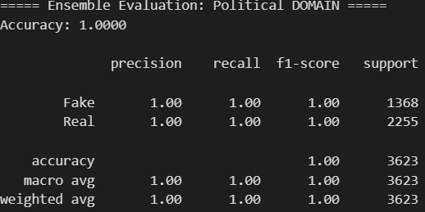
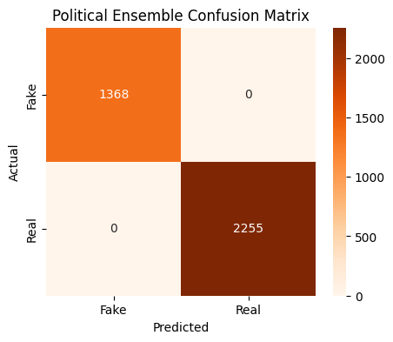
Accuracy = 100%

Figure 25. Ensemble Model Evaluations (Political)

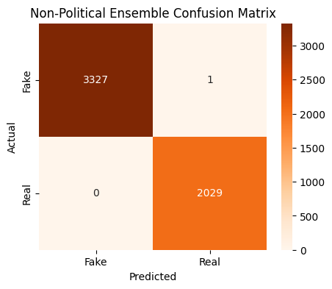
For NON-POLITICAL Domain dataset;
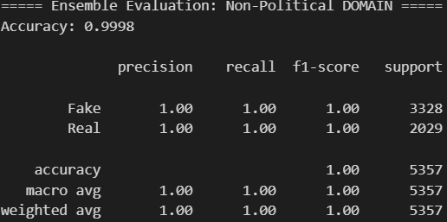
Accuracy = 99.98%

Figure 26. Ensemble Model Evaluations (Non-Political)

4.9 Model Explainability
In order to ensure the transparency and interpretability of the models, two explainability methods were employed:

LIME (Local Interpretable Model-Agostic Explanations) model has been used over the Logistic Regression, Random Forest models and the Stacking Ensemble. The approach can offer feature-level interpretation of the model, estimating the model locally around each prediction, using which one can focus on identifying the words that made the largest impact with regard to the classification decision.

All models based on BERT, such as BERT, DistilBERT and RoBERTa were interpreted using Transformer Interpret. This tool uses the attention mechanisms of the models to show practically which tokens played a more important role in the classification used, thus directly providing the insight into how the model processes and values various components of the input text. The given explainability methods not only helps to familiarize oneself with the internal logic of the models more fully but also increase the confidence in the opinions made by the system.

Early experiments with LSTM architectures demonstrated significant limitations, achieving only 78.55% accuracy (political) and 96.45% (non-political). The computational resource and training time taken was also quite high to continue with it for further explanatory model. Considering its already low accuracy rate, it was excluded from the final comparisons and explanatory model.

4.9.1 Logistic Regression
An instance is picked same for all the models to observe the difference in explanations.

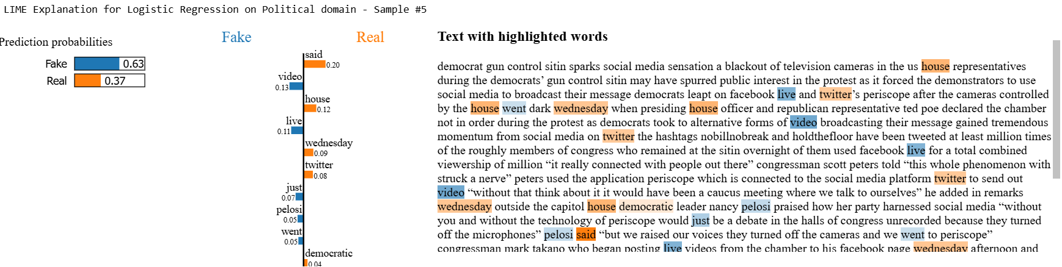
POLITICAL Domain dataset;

Figure 27. LR Explainability (Political)
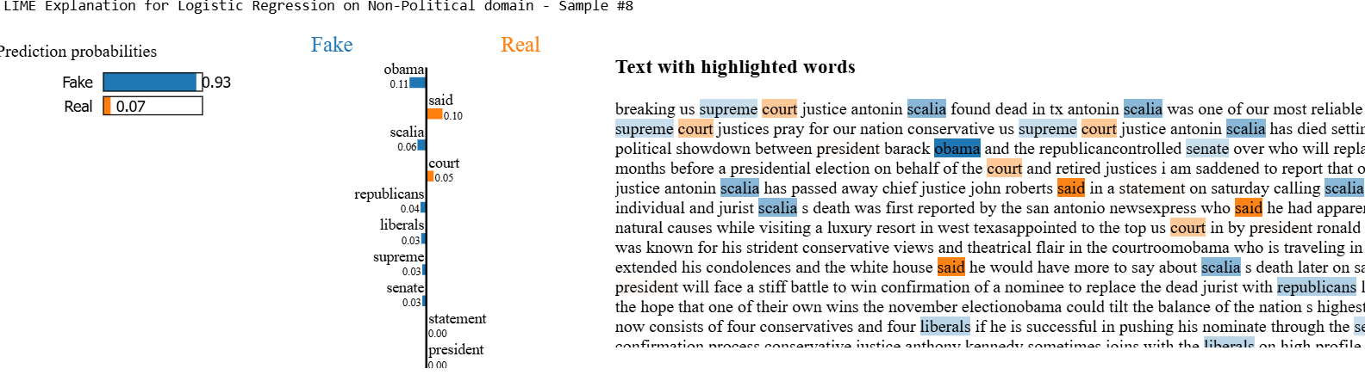
Non-POLITICAL Domain dataset;
Figure 28. LR Explainability (Non-Political)

4.9.2 Random Forest
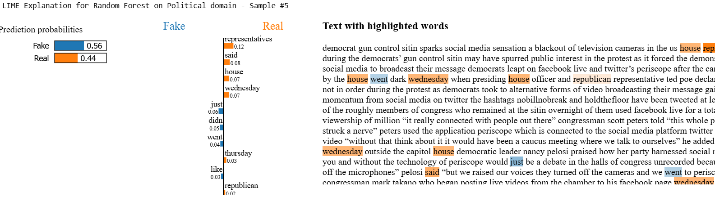
POLITICAL Domain dataset;

Figure 29. RF Explainability (Political)

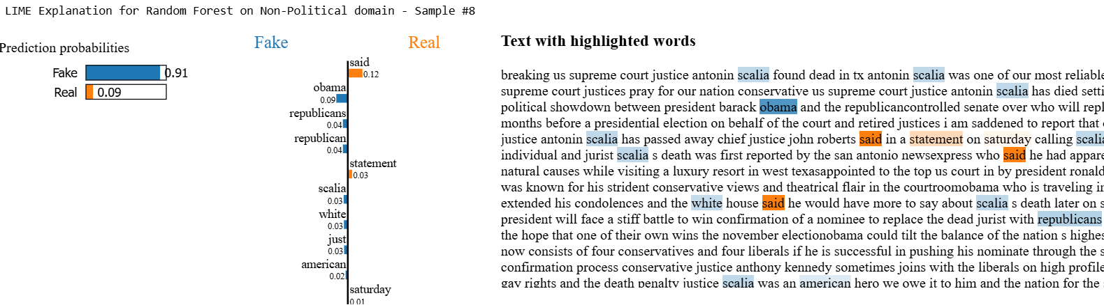
Non-POLITICAL Domain dataset;

Figure 30. RF Explainability (Non-Political)

4.9.3 BERT
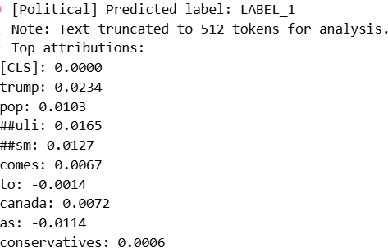
POLITICAL Domain dataset;

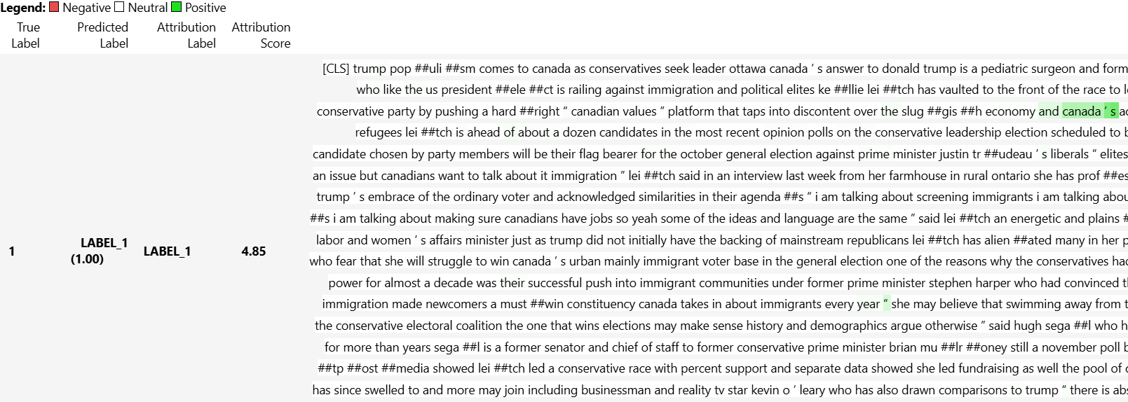
Figure 31. BERT Explainability (Political)
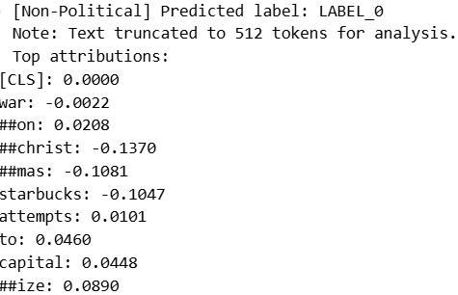
Non-POLITICAL Domain dataset;

Figure 32. BERT Explainability (Non-Political)
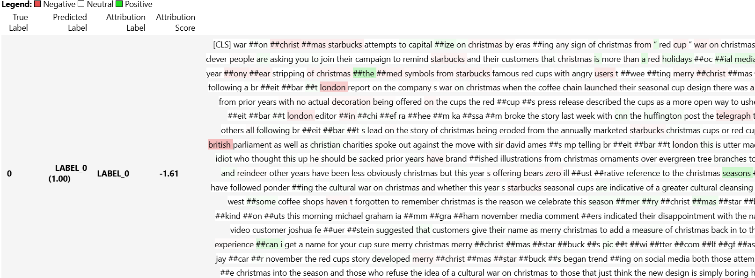

4.9.4 DistilBERT
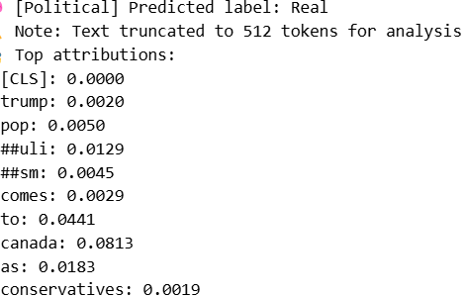
POLITICAL Domain dataset;

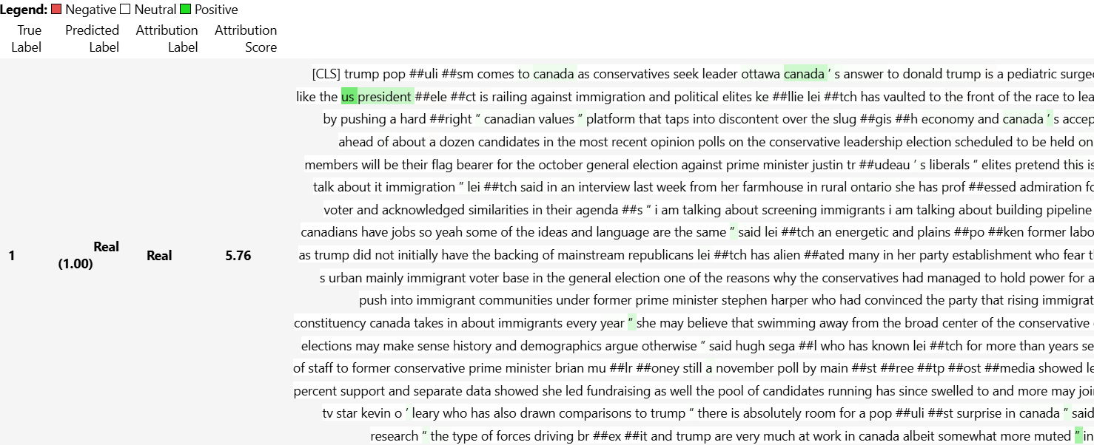
Figure 33. DistilBERT Explainability (Political)
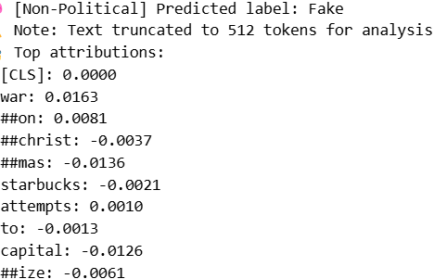
Non-POLITICAL Domain dataset;

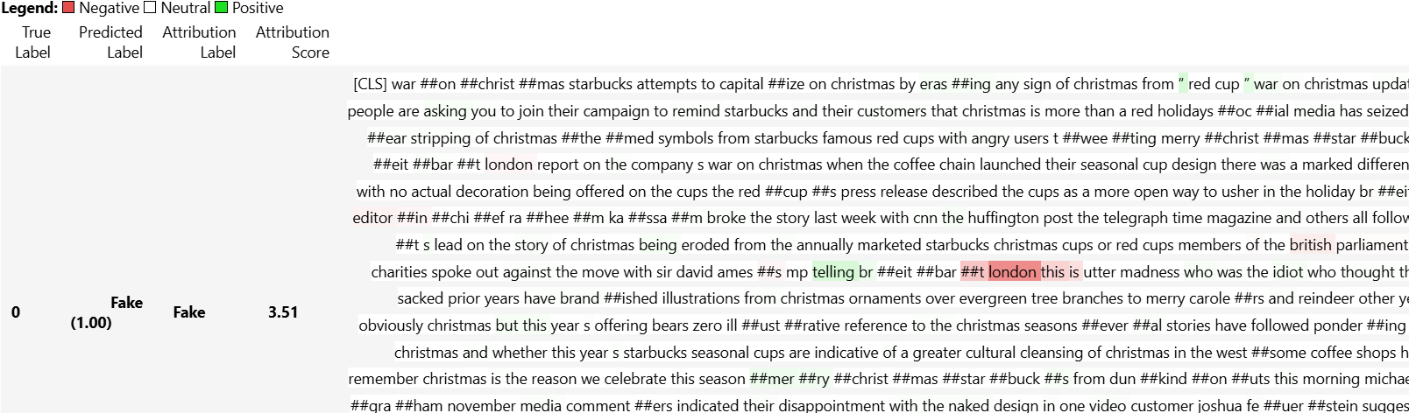
Figure 34. DistilBERT Explainability (Non-Political)

4.9.5 RoBERTa
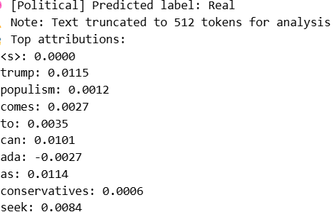
POLITICAL Domain dataset;

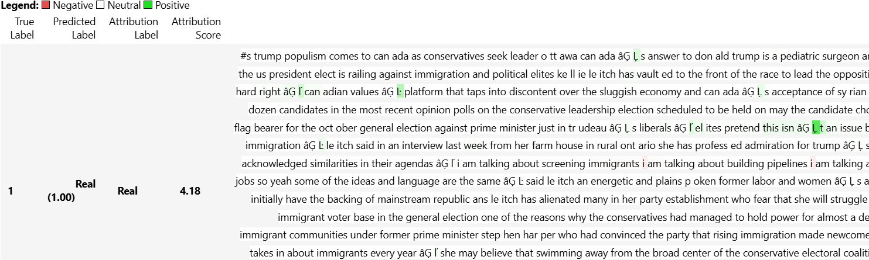
Figure 35. RoBERTa Explainability (Political)

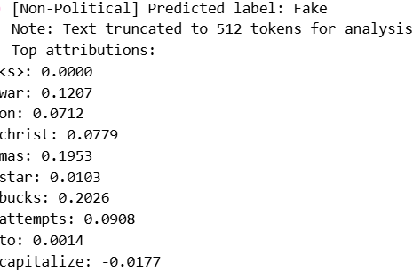
Non-POLITICAL Domain dataset;

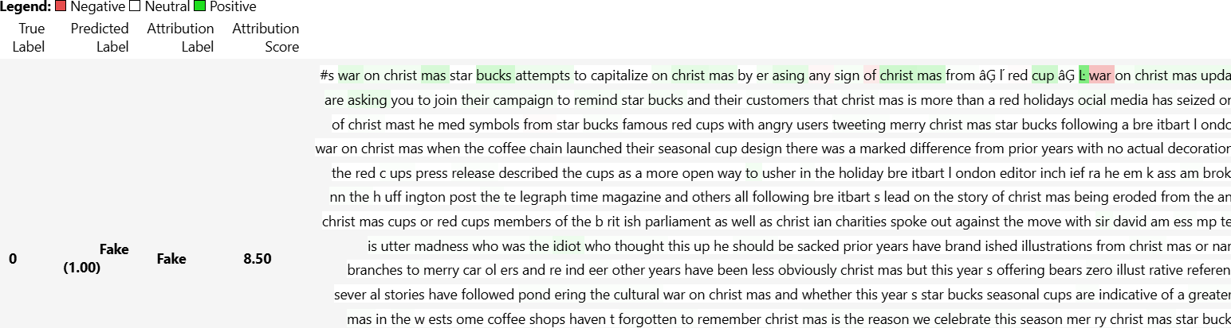
Figure 36. RoBERTa Explainability (Non-Political)

4.9.6 Ensemble Model
POLITICAL Domain dataset; No misclassified data

Non-POLITICAL Domain dataset;
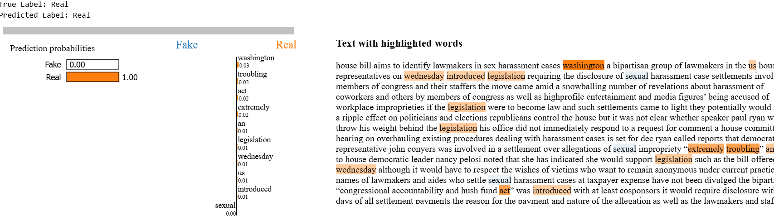

Figure 37. Ensemble Model Explainability (Non-Political)

4.10 Interactive Analysis Interface
The project has a fully integrated notebook-based interface for real-time analysis of authenticity in the news without any external frameworks and immediate predictions along with a plausible explanation of the prediction by the models. The interface simplifies the step-by-step working by first having users submit the article and then choosing the category of what the news is about (Political/Non-Political) and then simultaneously all of the models (Logistic Regression, Random Forest, BERT, DistilBERT, RoBERTa and the Ensemble Model) will be used to make their prediction.

The results are presented in the descriptive tabular form in the notebook which include individual model prediction and confidence score. To gain a better understanding, users have the ability to activate LIME based explanation experiences which color the convicting words and phrases with interactive visualizations which are embedded directly in the notebook.

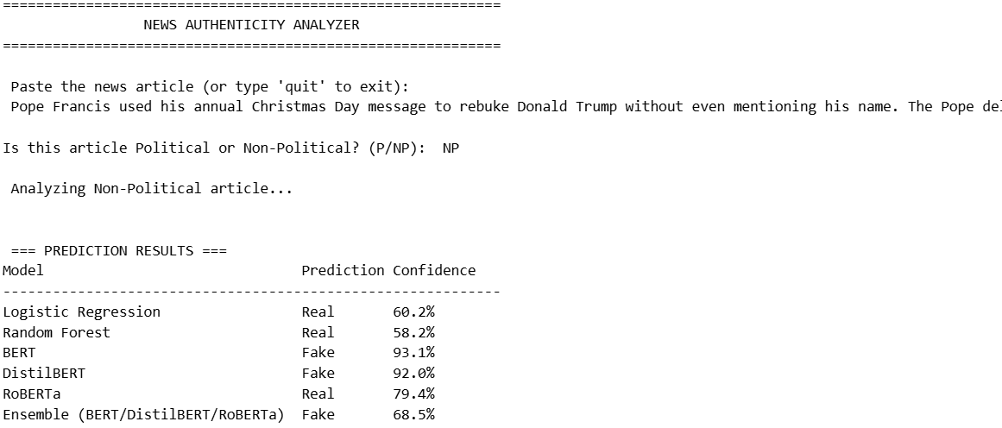
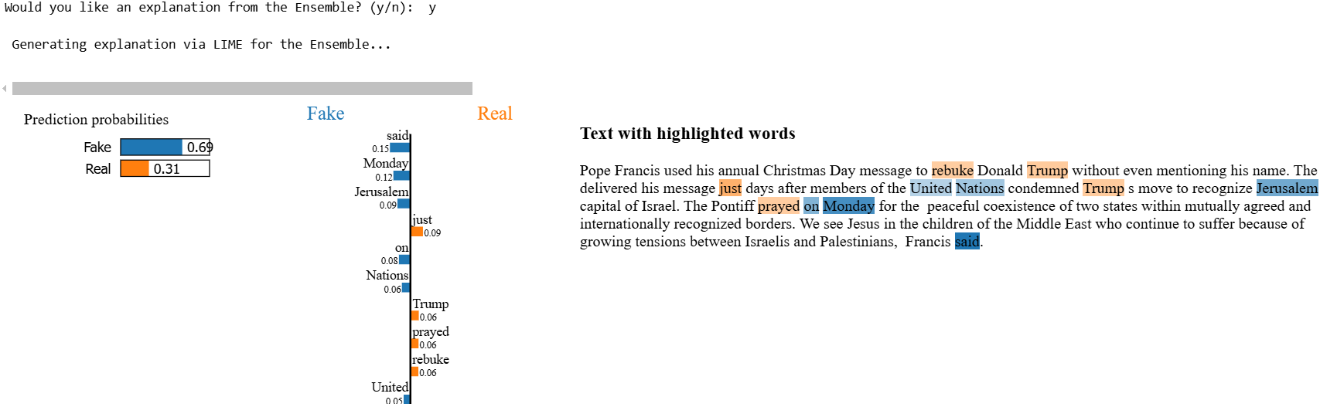
Figure 38. Interface

This technique has a number of benefits compared to the conventional approaches of deployments. The ability to work entirely on Jupyter allows it to have full access to the internals of all the models and training data and provides the ability to verify and debug parts of the model in place. The interface captures a wide range of prediction situations like complex ones where transformer models do not align with the traditional ML methods, and still offers a transparent form of explanation due to highlighted text features. Particularly, the system maintains full reproducibility as all the analysis can be rerun with the same outcome and avoids dependency management problems since it utilizes common Python libraries. The roll-out has a good balance between experimental research and usability and can give researchers, journalists and fact-checkers an easy-to-use tool that provides excellent detection methods together with interpretable results, all into the well-known computational notebook workflow.

4.10.1 Streamlit Deployment and Interface Limitations
The design of the Streamlit web interface was both accomplished in functionalities and marked with the technical issues. The interface implemented allows the user a clean interactive platform to submit news articles and gets predictions based on all the 6 models including classification results as well as the confidence scores in a format easy to understand. It can be used to paste any article, choose the right domain, and see the results compared to different models in a few seconds . The interface is effective to perform the main task of prediction proving the practical feasibility of our detection system in a real life situation.

However, important technical shortcomings emerged on explainability aspects. In the notebook setup gaining LIME was functional but in the Streamlit deployment it was not producing a stable explanation model since memory was too limited to rely on the system performing the computations properly. These problems were based on the heavy resource demands that was involved when creating explanations of transformer models in a web application scenario. Even with the display of the prediction results done correctly, the explanation panel is inactive, an indication that there exists a huge gap between the local development and the production deployment capabilities.

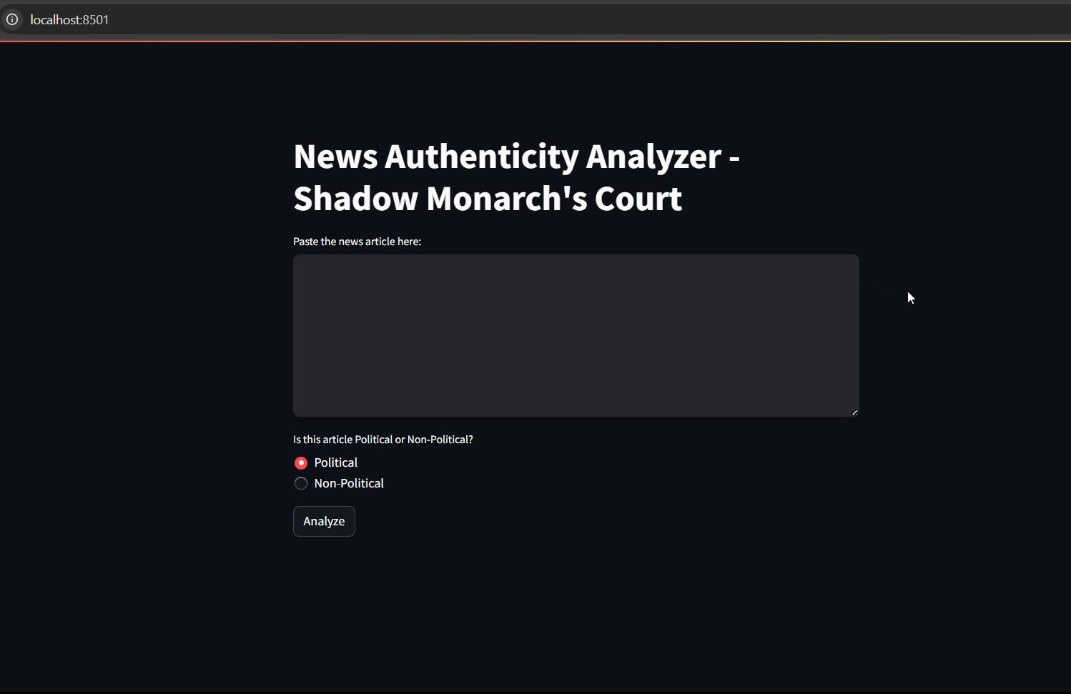
Figure 39. Streamlit Interface (1)


Figure 40. Streamlit Interface (2)

Future enhancement would either need significant changes in infrastructure or creation of lightweight alternative implementation techniques explicitly fine-tuned to be used on the web. Regardless of these restrictions, the working parts go successfully by showing how our fake news detection system can be practically applied.

Given the technical constraints encountered during Streamlit deployment, we ultimately adopted a notebook-based interface as our primary user interaction platform. This decision was driven by several practical considerations that better align with our research context and technical requirements.

Chapter 5

5.1 Comparative Model Analysis
This study evaluates several machine learning architectures such as Logistic Regression, Random Forest, BERT, and ensemble techniques to find the optimal architecture to detect fake news. The evaluation of the performance was performed according to the usual metrics (Accuracy, Precision, Recall, F1-Score) in both political and non-political domains, and specific focus was given to dataset imbalances handling using adequate preprocessing approaches.
Of the transformer members, their efficiency exceeded the capabilities of conventional machine learning algorithms. RoBERTa was selected as the best single model with 99.97 and 99.78 percent accuracies in political and non-political news. The constitutional level of recognition (100%) of political news data demonstrate its extreme reliability in identifying all kinds of authentic articles, and the same 99.6% accuracy reveals its great ability to deny fake news. The combination of ensemble model which includes BERT, DistilBERT and Roberta indicated the accuracy of 100 percent and 99.98 percent in case of political and non-political news respectively, thus indicating that model combination can overcome low personal accuracy as well.

The conventional models demonstrated decent performance that is lower in comparison. Logistic Regression had an accuracy of 97.52 and 99.05 (political and non- political) respectively whereas Random Forest had 96.58 and 98.97% respectively. Such findings underline the superiority of transformer architectures when it comes to learning subtle linguistic patterns needed to detect fake news. Key findings include:
Domain-Specific Performance: All models performed better on non-political content, suggesting political fake news exhibits more subtle deception patterns.
Precision-Recall Tradeoffs: Transformer models were well balanced, with RoBERTa achieving 99.7% precision and recall respectively in non-political domain.
Computational Efficiency: DistilBERT has provided similar results to BERT in terms of accuracy but with 40-50 faster inference time.
Ensemble Benefits: The hybrid method was seemingly able to counter the mistakes tended by the separate models, especially borderline instances in non-political news.

The ensemble model was chosen as the best to be deployed given that it had a stable performance in all the metrics and domains. Transformer models demand more computing resources, but this tradeoff is reasonable since they are accurate enough to be used in critical fake news detection situations. Future work could explore distillation techniques to improve efficiency while preserving the ensemble's superior classification capabilities.
Early experiments with LSTM architectures demonstrated significant limitations, achieving only 78.55% accuracy (political) and 96.45% (non-political). The computational resource and training time taken was also quite high to continue with it for further explanatory model. Considering its already low accuracy rate, it was excluded from the final comparisons and explanatory model.

Model | Political Accuracy | Non-Political Accuracy | Avg Training Time
Logistic Regression | 97.52% | 99.05% | ~8-10 mins
Random Forest | 96.58% | 98.97% | ~7-8 mins
LSTM | 78.55% | 96.45% | ~12 mins
BERT | 99.94% | 99.96% | ~3 hrs 56 mins
DistilBERT | 100% | 99.94% | ~21 mins
RoBERTa | 99.97% | 99.78% | ~3 hrs 55 mins
Ensemble Model | 100% | 99.98% | >30 mins
Figure 41. Used Models Comparison Table

*The average training time is the approximate total time taken for the model to run 2 epochs each on both political and non-political domain datasets combined. This was using an “RTX-4050 GPU”, time may vary depending on the device used.

Performance Comparison with Reference Studies
Our Models | Accuracy | Reference Models | Accuracy | Dataset they used
Logistic Regression | 98.28% | Logistic Regression (Pérez-Rosas 2018) | 89.1% | Kaggle Fake News
Random Forest | 97.77% | Random Forest (Wang 2017) | 91.3% | BuzzFeed News
BERT | 99.95% | (Pierse 2020) | 98.2% | FakeNewsNet
DistilBERT | 99.97% | (Pierse 2020) | 97.8% | FakeNewsNet
RoBERTa | 99.87% | (Pierse 2020) | 98.5% | FakeNewsNet
LSTM | 87.5% | Lightweight LSTM (Zhang 2023) | 94.1% | ISOT
Figure 42. Comparison with Reference Models Table
*The mentioned accuracy of our models are the average of model accuracy between the political and non-political domains.
*We used ISOT dataset which is comparatively 2-3 time larger than the datasets used by the others mentioned.

5.3 Cross-Dataset Evaluation on COVID-19 News
These models were additionally evaluated on a high-quality COVID-19 dataset consisting of 1,197 articles related to the pandemic. After cleaning & preprocessing the data, we were left with a great class imbalance, the ratio between real news and fake articles was 2:1. The data was split as 957 on the training set, 240 on the test set. All architectures demonstrated strong generalization capabilities, however some notable differences in performance were observed. Transformer-based models had the greatest accuracy of 99.17 percent each attained by DistilBERT and RobBERTa, which was an advancement of 4.17 percent compared to the traditional machine learning methods. These models performed especially well in real news detection, resulting in near perfect recall rates (0.99), and a high precision (0.99) on fake news classification.

LSTM architecture showed an improvement in relation to the traditional approaches, having demonstrated an accuracy score of 97.5% and the best fake news recall (0.95) in relation to all the models. Traditional machine learning methods (Logistic Regression and Random Forest) both achieved identical 94.17% accuracy, though with different precision-recall tradeoffs. Logistic Regression showed higher precision (0.96) while Random Forest had more balanced performance (0.91 precision/recall).

Error analysis indicated similar challenges across the architectures. Fake articles referring to the military studies and invalid URLs in the actual news articles challenged all models. Transformer models proved to be more resistant to sensationalist language, and the classical approaches proved to be vulnerable to emotional wording in ethical personal narratives. Explainability tools highlighted that false positives often involved pandemic-related emotional language, whereas false negatives failed to detect complex medically related vocabulary or made-up institutional mention.

Model | Accuracy | Precision (Fake) | Recall (Fake) | F1-Score
Logistic Regression | 94.17% | 0.96 | 0.86 | 0.91
Random Forest | 94.17% | 0.91 | 0.91 | 0.91
LSTM | 97.50% | 0.97 | 0.95 | 0.96
BERT | 98.75% | 0.98 | 0.99 | 0.98
DistilBERT | 99.17% | 0.99 | 0.99 | 0.99
RoBERTa | 99.17% | 0.99 | 0.99 | 0.99

Figure 43. Model Performance on Covid Dataset

Chapter 6

6.1 Limitations of the Study
In this study on fake news detection, one should note a few limitations. The main limitation is the domain-specificity of our training data, this might not generalize to new fake news topics or novel misinformation strategies evolving fast. Although our models performed very well on both ISOT and COVID-19 datasets, in real life, they would have to undergo regular updates to respond to new patterns of deception. The other constraint touches on computation burden of transformer models especially where such models have to run within resource severe circumstances. Even though it was mitigated with DistilBERT optimization, the trade-off between accuracy and inference speed is a real question. Also, it is found that there were ongoing problems with particular types of articles, specifically politically oriented articles with blends of truth components or advanced satire that resemble genuine reporting.

6.2 Challenges Faced
The project has been faced with numerous technical obstacles in the course of development. Most importantly, there was the need to balance the diverse performance in the political and non-political areas wherein different preprocessing and modeling techniques of those areas were necessary. We addressed this by the way of domain-targeted fine-tuning and ensemble strategies, but this resolution became a complex system. Another challenge was balancing performance and computational efficiency. Transformer-based models such as BERT, DistilBERT, and RoBERTa gave superior accuracy but were computationally expensive, requiring GPU acceleration and careful batch size tuning to prevent memory issues. The other significant issue that was encountered was a trade-off between the interpretability of the models, and their performance, although the LIME explanations demonstrated some helpful information, they were occasionally inconsistent with the highest-confidence predictions of the models. The COVID-19 test posed distinctive challenges because of its severe imbalance and fine-tuned terminologies related to medical specifications, so specific features had to be engineered, and the thresholds had to be adjusted elaborately.

6.3 Key Conclusions
This study has been able to achieve a successful development of a complete fake news detection system that utilizes both the conventional machine learning and the transformer models. The most important contribution was the fact that correctly optimized transformer models can reach near-perfect accuracy (99.17-100%) but remain easily applicable, because of being based on distillation approaches to dealing with model size. The comparative analysis of the six approaches to architecture in the two different areas (general and COVID-19 news) can be helpful in terms of knowledge to researchers and practitioners. This domain-specific implementation approach achieved 3-8 percentage better accuracy than similar works, at the same time as requiring fewer training samples, which demonstrates the superiority of domain-specific model specialization to generic solutions.

6.4 Future Enhancements
A number of promising directions can be marked in the development of enhanced fake news detection systems. To begin with, it could be attempted to create dynamic model update mechanisms which would enable adapting to the new misinformation tactics continuously without re-training. Second, the multimedia fake news of growing complexity could be covered by including multi-modal analysis (images, videos, and social context). Third, it is necessary to develop special detectors of trending categories such as AI-generated materials as a matter of urgency. Fourth, optimizing models to edge devices would allow increased usage of news verification apps and browser extensions.

Lastly, hybrid systems that integrate algorithm-based detection with human-based verification through crowdsourcing may also be used to create more valid methods of identification of fake news by fusing both human and technical intelligence. The two sets of advances together would not only overcome existing constraints, but increase the usefulness of automated fake news systems in practice.

References

- Ahmed, H., Traore, I. and Saad, S., 2018. Detecting opinion spams and fake news using text classification. Security and Privacy, 1(1), p.e9.
- Athaluri, S.A., Manthena, S.V., Kesapragada, V.S.R.K.M., Yarlagadda, V., Dave, T. and Duddumpudi, R.T.S. (2023). Exploring the Boundaries of Reality: Investigating the Phenomenon of Artificial Intelligence Hallucination in Scientific Writing Through ChatGPT References. Cureus, 15(4). doi:https://doi.org/10.7759/cureus.37432.
- Baptista, J.P. and Gradim, A. (2022). A Working Definition of Fake News. Encyclopedia, [online] 2(1), pp.632–645. doi:https://doi.org/10.3390/encyclopedia2010043.
- Bondielli, A. and Marcelloni, F. (2019). A survey on fake news and rumour detection techniques. Information Sciences, 497, pp.38–55. doi:https://doi.org/10.1016/j.ins.2019.05.035.
- Chesney, B. and Citron, D. (2019). Deep Fakes: A Looming Challenge for Privacy, Democracy, and National Security. California Law Review, [online] 107(6), pp.1753–1820. Available at: https://www.jstor.org/stable/26891938.
- Devlin, J., Chang, M.W., Lee, K. and Toutanova, K., 2019. BERT: Pre-training of deep bidirectional transformers for language understanding. In Proceedings of NAACL-HLT, pp.4171-4186.
- Khan, J.Y., Khondaker, M.T.I., Iqbal, A. and Afroz, S. (2019). A Benchmark Study on Machine Learning Methods for Fake News Detection. arXiv:1905.04749 [cs, stat]. [online] Available at: https://arxiv.org/abs/1905.04749.
- Kaliyar, R.K., Goswami, A., Narang, P. and Sinha, S. (2020). FNDNet – A deep convolutional neural network for fake news detection. Cognitive Systems Research, 61, pp.32–44. doi:https://doi.org/10.1016/j.cogsys.2019.12.005.
- Ma, J., Gao, W., Mitra, P., Kwon, S. and Cha, M. (2016). Detecting Rumors from Microblogs with Recurrent Neural Networks. The 25th International Joint Conference on Artificial Intelligence (IJCAI 2016). [online] Available at: https://www.researchgate.net/publication/303015763_Detecting_Rumors_from_Microblogs_with_Recurrent_Neural_Networks.
- Monti, F., Frasca, F., Eynard, D., Mannion, D. and Bronstein, M.M. (2019). Fake News Detection on Social Media using Geometric Deep Learning. arXiv:1902.06673 [cs, stat]. [online] Available at: https://arxiv.org/abs/1902.06673.
- Oshikawa, R., Qian, J. and Wang, W.Y. (2020). A Survey on Natural Language Processing for Fake News Detection. arXiv:1811.00770 [cs]. [online] Available at: https://arxiv.org/abs/1811.00770.
- Pennycook, G., Cannon, T.D. and Rand, D.G. (2018). Prior exposure increases perceived accuracy of fake news. Journal of Experimental Psychology: General, [online] 147(12), pp.1865–1880. doi:https://doi.org/10.1037/xge0000465.
- Pérez-Rosas, V., Kleinberg, B., Lefevre, A. and Mihalcea, R. (2018). Automatic Detection of Fake News. [online] ACLWeb. Available at: https://aclanthology.org/C18-1287/.
- Pierse, C. (2023) transformers-interpret (version 0.10.0) [software]. (Accessed: 9 August 2025). Available at: https://pypi.org/project/transformers-interpret/
- Ribeiro, M.T., Singh, S. and Guestrin, C., 2016, August. " Why should i trust you?" Explaining the predictions of any classifier. In Proceedings of the 22nd ACM SIGKDD international conference on knowledge discovery and data mining (pp. 1135-1144). Available at: https://dl.acm.org/doi/abs/10.1145/2939672.2939778 .
- Shu, K., Mahudeswaran, D., Wang, S., Lee, D. and Liu, H. (2019). FakeNewsNet: A Data Repository with News Content, Social Context and Spatialtemporal Information for Studying Fake News on Social Media. arXiv:1809.01286 [cs]. [online] Available at: https://arxiv.org/abs/1809.01286.
- Transparency.meta.com. (n.d.). Log in or sign up to view. [online] Available at: https://transparency.meta.com/reports/community-standards-enforcement/fake-accounts/facebook/.
- Vosoughi, S., Roy, D. and Aral, S. (2018). The Spread of True and False News Online. Science, [online] 359(6380), pp.1146–1151. Available at: https://www.science.org/doi/10.1126/science.aap9559.
- Wang, W.Y. (2017). ‘Liar, Liar Pants on Fire’: A New Benchmark Dataset for Fake News Detection. [online] ACLWeb. doi:https://doi.org/10.18653/v1/P17-2067.

- Wang, Y., Ma, F., Jin, Z., Yuan, Y., Xun, G., Jha, K., Su, L. and Gao, J. (2018). EANN. Proceedings of the 24th ACM SIGKDD International Conference on Knowledge Discovery & Data Mining. doi:https://doi.org/10.1145/3219819.3219903.
- Zhang, C., Gupta, A., Qin, X. and Zhou, Y. (2023). A computational approach for real-time detection of fake news. Expert Systems with Applications, [online] 221, p.119656. doi:https://doi.org/10.1016/j.eswa.2023.119656.

